Music Performance and Production – Music Branding – Yr 1.

Digital Skills.

This module is designed to develop your digital skills within the Adobe Creative Cloud.
You will be introduced to the software and create a body of work that demonstrates creative experimentation and investigation. Throughout the module from a series of workshops you will be required to document your work and create a portfolio of all your development work and outcomes on Digital Space.

Task 1:

You are to research and collate 8 – 10 images of existing band and/or musical artist logos. Write a brief description of your thoughts on each of these logos and why you think they are effective in communicating the brand values of the band or musical artist.

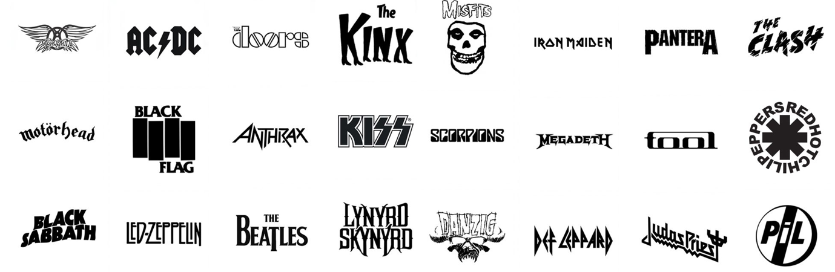

Task 2:

You are to brain storm the name of your band or you as a solo performer and through the process of thumbnail sketches develop a series of ideas for the development of your logo.

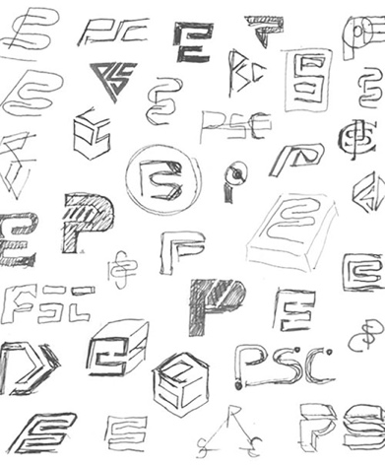
Task 3:

From your initial creative findings chose a design that you can develop through the digital design workshops on offer.

