Imagination, design and innovation, going beyond commerce

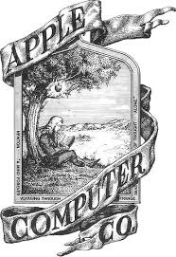apple

Design and privacy

One of the best manufacturing companies for tech

We believe that we’re on the face of the Earth to make great products

Byte into an Apple

Apple

Beautiful, effort invisible

No tech talk, build anticipation

High rank with competition

Sleek, high quality

Loyal customers