Research Week
During week 1 of your new project you are asked to complete the following.
- Research and consider the theme of ‘Culture’ linking to the brief requirements.
Create mind maps and mood boards to help you decide upon your chosen direction.
- Find at least 2 relevant artists relating to your considerations of ‘Culture’.
This may or may not relate to your specialist practice.
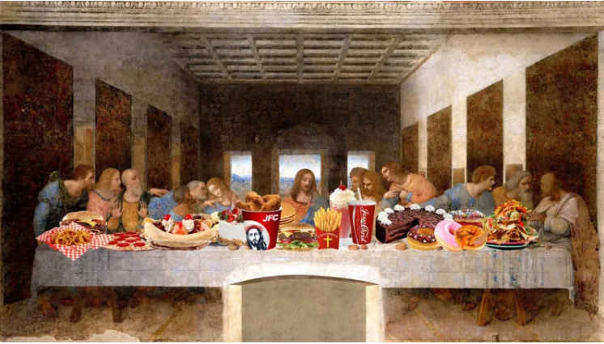
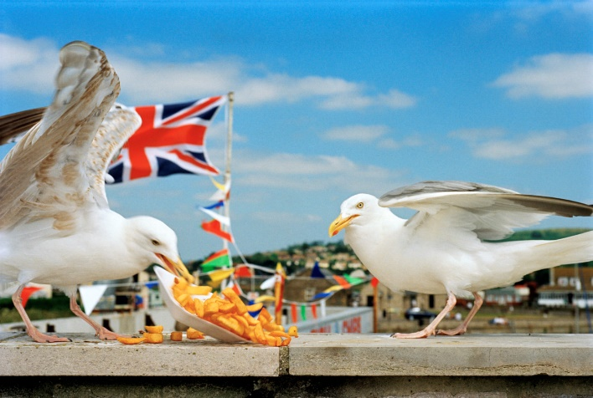
- Continue your specialist industry practice research from the initial project and find at least 2 artists who link to this to study.

Remember, a good website for artist research is artsy.net
LO1 Investigate the materials associated with a specialist industry practice
LO2 Investigate the technical skills associated with a specialist industry practice
LO3 Investigate creative processes associated with a specialist industry practice
LO4 Solve problems within a specialist industry practice
LO5 Use safe working practices with a specialist creative environment
LO6 Use specialist industry practice presentation techniques to present work

