If we are to preserve culture we must continue to create it.
Johan Huizinga
What is Culture?
“Culture is a set of shared and enduring meanings, values, and beliefs that characterise national, ethnic, or other groups and orient their behaviour.” – Joan Mulholland
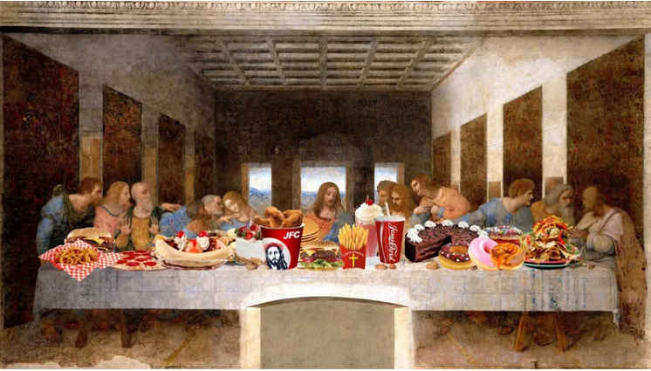
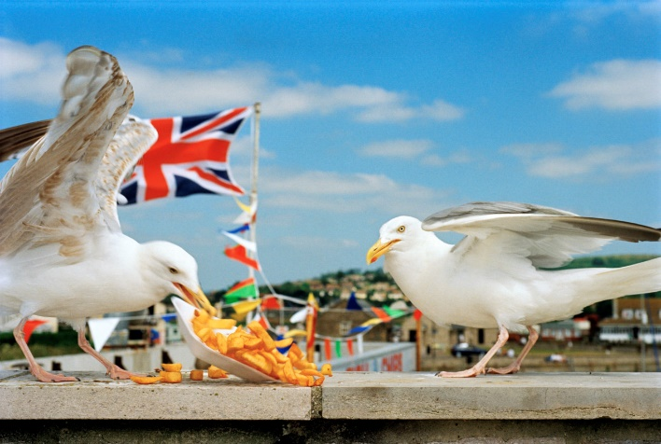

Assignment Brief
You will consider the project theme of culture, what it means and more specifically what it means to you. You should use idea generating techniques and undertake initial research before proposing a response to the theme. You are encouraged to interpret the theme in a broad sense but it should reflect something that you consider to be part of your culture.
This unit requires you to explore in-depth the skills and creative processes associated with a chosen specialist industry practice. You will be required to refine your understanding of your chosen specialist industry practice through focused material and process led exploration and experimentation.
You will develop an understanding of the specific materials and technical skills used within your specialist industry practice to solve problems and develop outcomes relevant to your specialist industry practice.
You must apply safe working practices, as you develop and refine your technical skills, and ensure that you use appropriate specialist presentation techniques to demonstrate your technical skills.
Throughout this unit you will be expected to reflect on and evaluate your performance to inform personal development within the context of your chosen specialism.

Learning Outcomes
LO1 Investigate the materials associated with a specialist industry practice
LO2 Investigate the technical skills associated with a specialist industry practice
LO3 Investigate creative processes associated with a specialist industry practice
LO4 Solve problems within a specialist industry practice
LO5 Use safe working practices with a specialist creative environment
LO6 Use specialist industry practice presentation techniques to present work
ISSUE DATE | w/c 14th November 2022
DEADLINE | w/c 30th January 2023

