Assignment Brief: Level 2 Diploma in Art & Design UAL
Date issued: 12th September 2022 | Hand in deadline: 13th October 2021
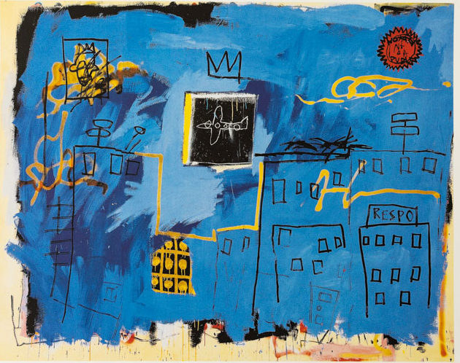
“Colours speak all languages” Joseph Addison
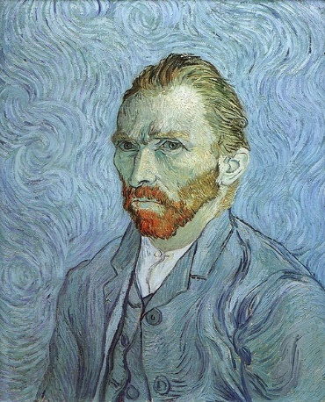
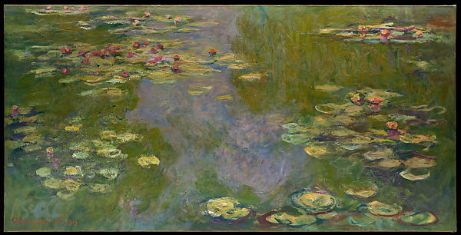
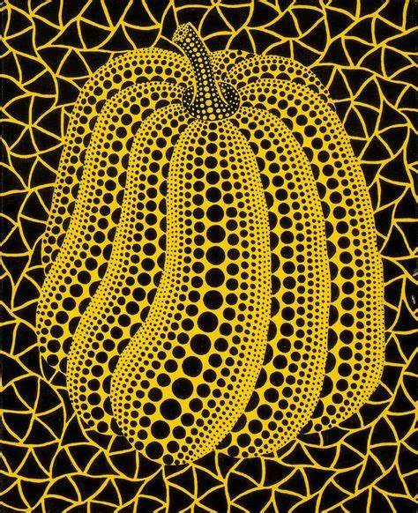
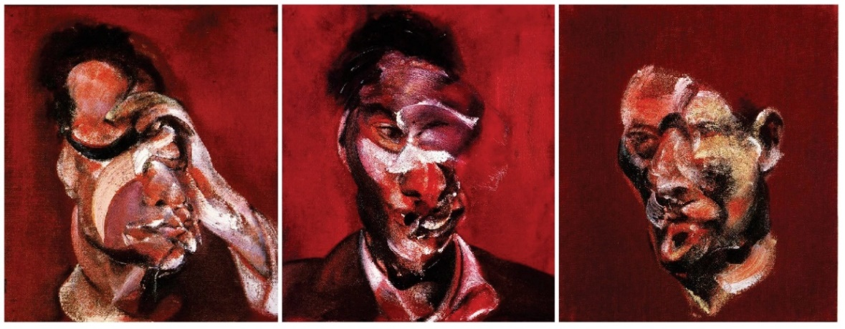
Brief

For your first brief on Level 2 Art and Design, you are asked to pick any colour. With that colour, create artwork using different mediums and techniques exploring elements of visual language.

You will…
- Undertake primary research
- Experiment with materials techniques and processes in workshops.
- Investigate relevant artworks from artists and designers.
- Document and analyse the effectiveness of your visual language experiments
- Present evidence of your work representing your chosen colour.

The UAL Learning Outcomes for this project are:

- Unit 1: Students will understand materials, processes and technical skills in art and design.
- Unit 2: Students will understand art and design contextual research.
- Unit 3: Students will know how a range of light sources affect the appearance and meaning of subjects and be able to use a variety of drawing media to record the effects of light.

- Unit 6: Students will be able to use materials, processes and technical skills in 3D art and design.

This work should be collated in your sketchbook for assessment.

nb. The presentation of your work should always be considered. Written work must be proofread to correct any spelling and grammar mistakes.

Artists featured:
Jean Michael Basquiat, Monet, Vincent Van Gogh, Frances Bacon, Yayoi Kusama, Kimiko Yoshida

