**Evaluation Process**

***What methods did you use to maintain an ongoing evaluative and reflective approach?***

I made notes of my strengths and weaknesses and the mistakes throughout the process of this project to help with reflecting.

***What reflective model did you use, if any?***

Using bullet points to note down my journey throughout the project.

***Rate the thoroughness of your evaluations.***

The thoroughness of my evaluations has helped me through reflecting my journey throughout the process of this project.

**Evaluation Influencing Your Work**

***In what ways did you use evaluations to influence your decision making?***

I watched a lot of supernatural movies and series about young woman with magical abilities, which has always been fascinating to me because I think the idea of someone being capable of unhuman abilities is exciting and the way movies and tv series portray this with the actors is remarkable in my opinion. I just wanted to portray the concept of a misunderstood young woman, trying to discover herself in a way that leads to tragedy.

***How effective was your evaluative process in influencing your decision making throughout your project?***

It was very effective as I chose to keep the main idea and concept of the film, I had kept everything I came up with in the process.

**Project Development**

*****Did you meet your stated aims?*****

**My aim of this film was to show that bullying isn’t acceptable, and people underestimate Women’s capabilities especially at a young age, so the aim of the story is to give the message to not underestimate anybody’s capabilities and to take into consideration of other people’s feelings.**

*****How does your work compare with your professional research?*****

**It compares with my professional research, as I used some of the professional camera shots in filming and some directing techniques.**

*****Did you make any changes? Why? How did your concept develop?*****

**I made a few changes during production, but this didn’t really change the concept of the story. At the beginning I had the idea of giving Henry’s character ‘Max’ a back story of his mother being a witch and I was going to have my younger brother play his younger self in a flashback scene. To be honest, this idea was genius from me, but I decided to change it and not use a flashback scene as the movie is about Esme and not Max so It wouldn’t really make sense to give him a backstory. So I changed the script on the last scene for Max to shout nasty insults at Esme as he’s underestimating her and teasing her which leads to a mind blowing tragedy of an ending. I feel like deciding to make this change made an very effective impact in the concept and the aim of the story.**

*****Does the finished product appeal to the target audience?*****

**The target audience is mainly 15 age rating, I rated the age 15 as it contains vulgar language and disturbing events. I think the finished product appeals to the target audience as its about a teenage girl discovering her capabilities and some teenagers can some-what relate to that (obviously without the murderous special abilities).**

*****How well does the product reflect your skills and the things you have learnt this year?*****

**This year I have impacted on my skills a lot more and also learnt new skills I'd never thought I'd need. My reflective skills have improved a lot since the previous projects, I have learnt how to work as a team and take other people’s thoughts and ideas into consideration.**

*****Is it an accurate reflection of your skills? Are you proud of it?*****

**I am very proud of the project as it is my first time experiencing a opportunity like in my life and my first time being part of a production let alone make one. It has been an amazing experience and I would definitely pursue an opportunity like this again if given to me. I am really proud of my production for this project but also I am really proud of my class mate Henry Mulligan, as his production within this project is very impressive as he also is experiencing this for the first time and I say this with no disrespect at all because everyone else’s productions are amazing but, I feel like the mine and his movies are the best productions in the whole project.**

*****What would you do differently next time? What did you learn?*****

**Next time I would give myself more time on planning and writing the script, I would make sure I have access to editing programmes and more knowledge on how to use them and their functions correctly. I would plan out crew meetings before filming, to make sure everyone is still on board with the Production so I know that cast won’t cancel on me the day of. I would make sure I have access to all the equipment required, instead of borrowing equipment, so I'm not relying on the person to provide me with it when I have it in my own possession.**

*****What would you do differently if you had a larger/unlimited budget?*****

**If I had a larger budget, I would hire out locations like buildings etc. I would build sets, hire out more technical equipment for different cinematic shots. I would hire out professional actors or acting classes for the actors, set rehearsals, more camera crew, more editors, graphic designers etc.**

**Final Product**

***Rate your commitment to and engagement with the project.***

I was 100% committed to this project, more committed to anything I have taken part of before. My commitment helped the process of the production get to the highest standard I wanted, even though it didn’t go to the highest standard I wanted, it still worked and it went to a decent standard that I can work with. But if I didn’t show any commitment, I think it would not be as near as successful as it is right now. My commitment and engagement with this project has over drawn me to stress which I now know that I have to work on that and try not get too stressed out during producing an important project.

***What professional qualities have you demonstrated during this project?***

I had enrolled the responsibility of being a director, which I could have been more professional with, but I have demonstrated professional qualities like, having an eye for different camera angles and shots, how actors should engage emotion when acting in heart felt scenery.

***Discuss and assess the success of your final product/performance.***

The film is now up on YouTube.

[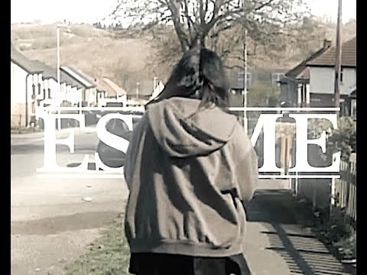](https://www.youtube.com/watch?v=VMPwX5u7P9A&t=442s)

I think the production is very successful as I have had a lot of positive feedback in the comment section of the film, and also I have had my friends message me and tell me some positive comments about it. I personally think that this production is one of the best ones in the project.