 |  |  |  |  | 
 |  |  |  | Performing arts as a student at Bradford college  Age: 18  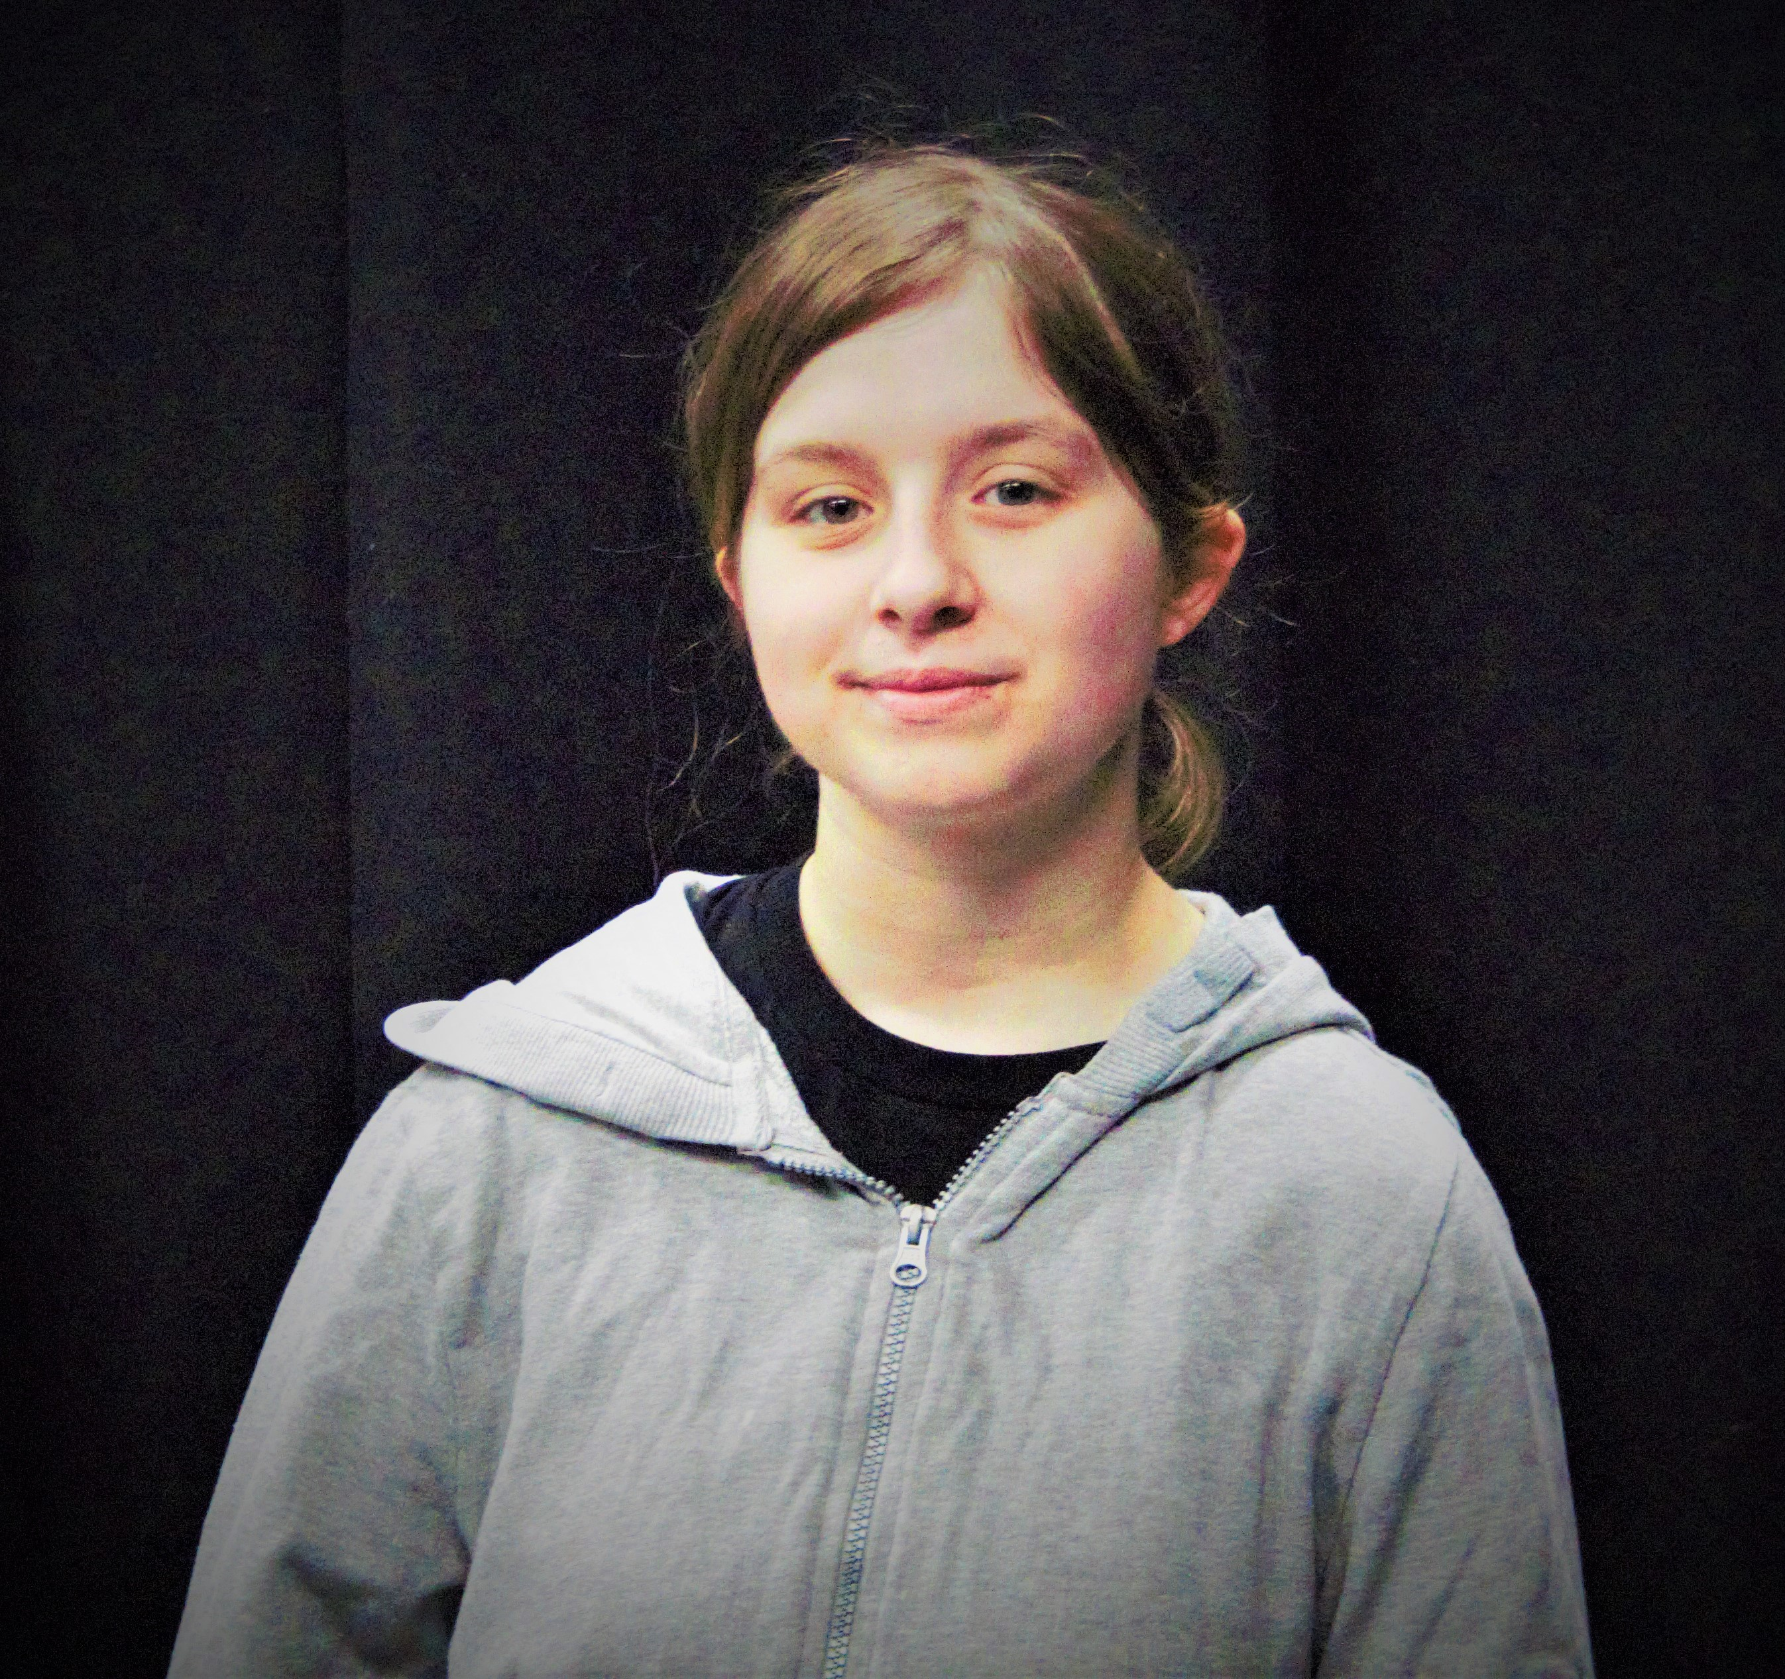  Date of Birth: 19/06/2004  Where I am born: United Kingdom  Hair: browny blond  Eye: blue/green  10671620@Bradfordcollege  Skills: Acting, singing, and dance  GCSE  Childcare level 1, Health and social care level 2, Functional Skills English, Performing arts level 2  Double-click  Sincerely,  [Your Name]
[Your Address]
[City, ST ZIP Code]
 | [Your Phone]
 | [Your Email]
 | Your Website

