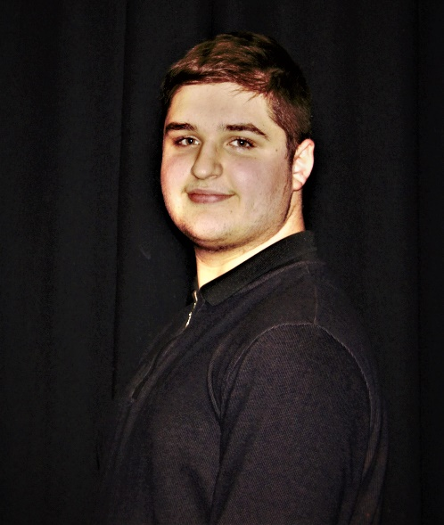
Lucas crane
agent: bolt actors management contact: 012345 666789
address: Keighley email: 10665264@bradfordcollege.ac.uk
Hight: 5:11 weight: ? Ethnicity: Caucasian
Age: 16 Location: Yorkshire playing age: 16-18
Hair: brow eye colour: hazel gender identity: male
Build: chubby pronouns: he/him playing gender: male

Credits
unknown name Alhambra theatre
a Christmas carol fred Bradford college
friend’s re-enactment joey Bradford college

