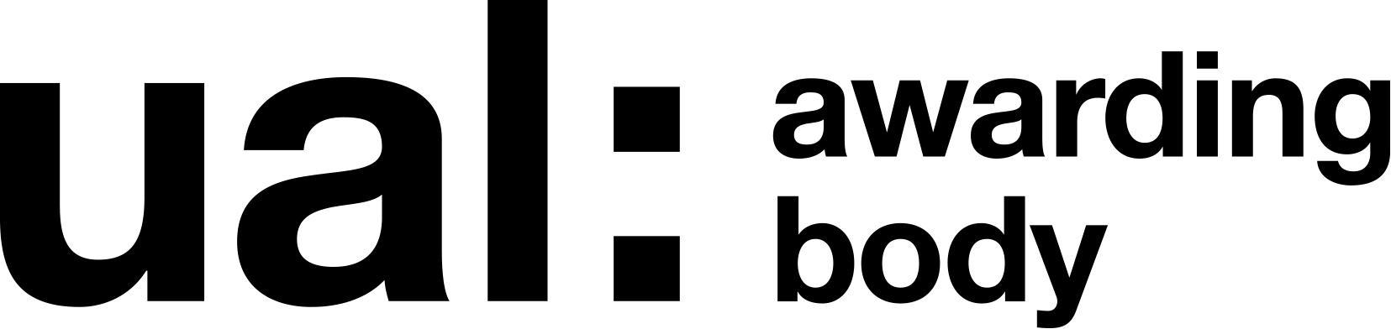

**UAL Level 3 Diploma a in Art & Design: Creative Practice and Communication**

**UNIT 3: Written Evaluation**

**800 words**

All sections have an advised word count.

A 10% tolerance is applied.

Your evaluation must be typed and included in your project folder along with your proposal, Pecha Kucha, mid-stage review and final self-assessment.

The Unit 6 evaluation provides you with an opportunity to reflect on, evaluate and summarise your progress and achievements in your final project, expressed in terms of the knowledge, skills and understanding acquired.

It’s important to compare what you now know, and what it means to you, compared with what you knew and could do before you started the course.

Allow plenty of time to complete your evaluation. It contributes to meeting the following Unit 3 outcome:

**AO8 -** Apply reflective practice to a creative project.

|  |  |
| --- | --- |
| Student Name: | Austin Goacher |
| Centre Name: | Bradford College, Lister Building |
| Centre Number: | 37122 |
| Pathway Specialism: | Art |
| Working Title of Project: | Memories Project |
| Date: | 18/05/2023 |

|  |
| --- |
| **AO1: Understand the requirements of a set brief within a vocational context. (approx 100 words)** |
| * Explain your reasons for choosing a particular project theme/concept and outline in response to the set brief. * What ethical considerations have you taken into account? * What cultural considerations have you taken into account * What sustainability considerations have you taken into account? * What were the reasons for citing your project within your selected vocational context? |
| I chose the project brief “we opened them up and it was like Pandora’s box” as it was an easy connection to the theme of mythology through the reference to Pandora’s box. This led to me specifically focusing on Chang’e through the angle of mythology. Ethically I have made sure to go with a theme focus that doesn’t have harmful or disease based connotations as this may be triggering for the intended recipient of the work while culturally I have gone beyond the Eurocentric mythologies to focus on a Chinese goddess as most mythological work is based on Eurocentric cultures like Greek and Norse while occasionally also Egyptian and Japanese mythology. Sustainability wise I made sure to only use what I already had to make the work and will be making my own frame in the form of a Chinese hanging scroll. |
| **AO2: Plan and realise a project in response to a brief. (approx 100 words)** |
| * How well have you used your time at college and at home? What are the factors that influence your time management? * Have you been under- or over-ambitious in your project work? How might you go about resolving any issues? |
| I believe I used my time at home well considering I also have responsibilities at home that had an influence on my time management. I believe I was initially over ambitious with my timescale and work but was able to correct this by focusing more into digital space to do things such as clouds instead of doing them by hand like with my rabbit. In the future I will resolve this issue by being more considerate of my time frame and making sure to start on some things early so I won’t run out of time. |
| **AO3: Use research to inform a creative project. (approx 100 words)** |
| * How have primary observations, experiments, initial material developments and technical engagement supported the developing understanding of your subject? * How have other people’s ideas and working methods interested you? *(secondary research; ethical, social, cultural etc)* * Explain how you think these ideas and methods have supported and nourished your development? |
| My primary observations have assisted with the rabbit aspect of my work by helping me link Rabbits to Chang’e as well as how to draw rabbits with basic shapes for their bodies, etc. I also used material practice to decided what form to do my moon in and on what sort of paper, eventually decideing on doing it in water colour on the same paper as Chang’e but also reducing its size so it was like a orb in her paws. My artist research inspired me to use water colour but also do clothing for my rabbit especially the scarf that is always worn by Chang’e in ancient and modern media. These ideas have helped me to try paths I would initially not have considered for this project and develop on my initial ideas as well. |
| **AO4: Use practical skills to meet the requirements of a brief. (approx 100 words)** |
| * Reflect on all the practical processes and skills you have explored, adapted and developed throughout your project. How appropriate were they to the development of your project? * Which processes and skills have you been interested in the most and why? * How effective have you been at mastering the techniques, processes and skills selected? |
| I have developed my skills in watercolour and digital media, particularly the latter in the later stages of the project, while also adapting how I draw rabbits to be a mesh of realism but also incorporating more cartoon-based aspects as well as those have always been an influence to my style. I have been most interested in the digital processes as those put the most influence into my final piece, particularly in shading using the gradient tool as that had a great effect on my work. I believe I did well developing my digital techniques and also wish to develop them more in the future as well. |
| **AO5: Generate and develop ideas in response to a brief. (approx 100 words)** |
| * Reflect on those significant aspects of your work (failures and successes are of equal importance) that you have had to resolve in order to progress? * How well have you adapted to unforeseen practical and technical problems? * What factors have influenced your ability to solve problems in the most effective and appropriate manner? |
| A significant aspect of my work that I had to correct was accidentally using the wrong layer for part of my final piece leading to me needing to edit around this aspect, particularly for my tree as the issue was on the same layer as part of my tree. I also had issue uploading my work to digital space but quickly corrected my issue with some assistance. As such, I believe I have adapted well to my problems during this project in both technical and practical aspects and I have been able to do as such through the help of my teachers as well as my own perseverance despite issues with my own emotional stability at times. |
| **AO6: Produce outcomes in response to a brief. (approx 100 words)** |
| * Explain your reasons for selecting the ideas and methods chosen for **producing** your final outcome(s). * How do these outcomes relate to your audience? |
| I used a mixture of water colour and photoshop for my final piece as those mediums hold a link to both my past and possible future in art and have been influential in my journey, I also chose to display using a Chinese Hanging scroll as it links to the origins of Chang’e and her myths. These outcomes relate to my audience as they effect how they may perceive my work and connotations they may draw from it. |
| **AO7: Present development work and outcomes. (approx 100 words)** |
| * Explain your reasons for adopting the strategies you chose when **presenting** your project and final outcome(s). * How appropriate are they to your developing professional practice? * How effective have you been in communicating your ideas? |
| I adopted the strategies I did for displaying my final piece because they related to the origins of my project and would allow me to use another method in my final piece as well as what I had initially chosen to do and means it can be easily displayed on a wall. They are appropriate as I am still developing my style and working on new ways to work and develop in art. I believe I have been decently effective with communicating my ideas as I have written out my thoughts and done sketches of any and all ideas I have had for my work within my sketchbook for easy access to it. |
| **AO8: Apply reflective practice to a creative project. (approx 100 words)** |
| * Identify the aims and objectives that you were interested in developing when you started your final project. How effective have you been in reflecting on your developing work and progress against these targets? |
| My aims and objectives when I was starting my project was to create an interesting piece to show of Chang’e in a way that hadn’t been commonly explored before and I believe my piece achieved this. I used mixed media as well as a different portrayal of Chang’e in the form or a rabbit which I believe makes my piece fit into the objective that I had set for myself as well as cute which will make it a good fit for the objective of this project as a whole outside of my own individual endeavour of the work. |