Ashley Dunne 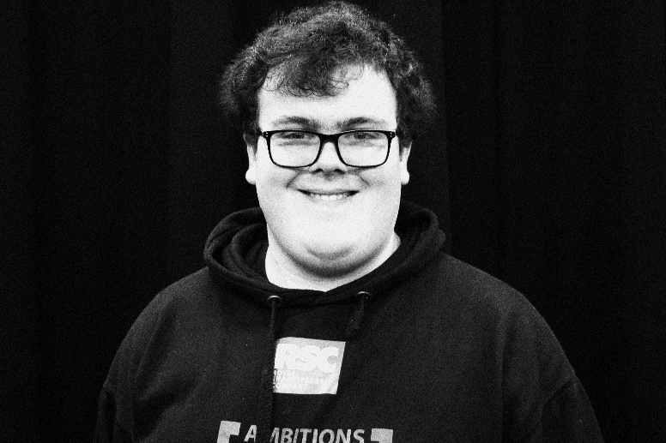
My acting cv new version
07513103564
Ashleyrdunne@gmail.com
40 Scholemoor road lidget green Bradford BD72PD
Height 5ft 6in
Weight 12 stone eleven
Eye colour green
Hair colour brown
Age 16- 30
Birthday 31/03/2006

Productions characters venue

Stage devised theatre - ensemble Bradford school of art 2023.
Pantomime- sneezy Bradford school of art 2023.

Tv peaky blinders- Danny whizzbang Bradford school of art 2024
Grim life grim brother one and pupil one
A Christmas carol jack Bradford school of art 2022
Twelve-night Sir toby belch RSC playmakers festival 2023
Dance united project dancers dance united 2023.
I attended Shakespeare workshops and dance united workshops and screen Yorkshire workshops.
My specific skills are.
I can do accents Scottish, Irish, scouse, English.
For dance I can do jazz and contemporary freestyle
I can sing songs I am good at instruments.

