**Ashley Dunne** 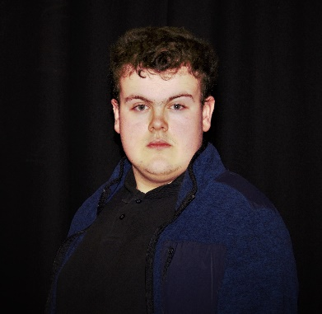

**Contact details**

**Email** [**10662635@bradfordcollege.ac.uk**](mailto:10662635@bradfordcollege.ac.uk)

**Address: lidget green Bradford west Yorkshire BD72PD**

**Height 5ft 6in Weight: 9ibm**

**Age: 16 Birthday: 31st march 2006**

**Playing age:16- 22 ethnicity: white European**

**Location: Bradford college hair colour: dark brown**

**Gender identity: male gender playing: male**

**Build muscular pronouns him/he**

**Skills**

**Languages English, Irish**

**Accents: Irish, cockney, scouse**

**Sports: cricket, rounders, long jump, triple jump, rugby and shotput**

**Dancing: Jazz, comtempary**

**Disabilities speaking problems**

**Credits**

**A night at the musicals**

**A Christmas carol**