Post Malone concert Posters

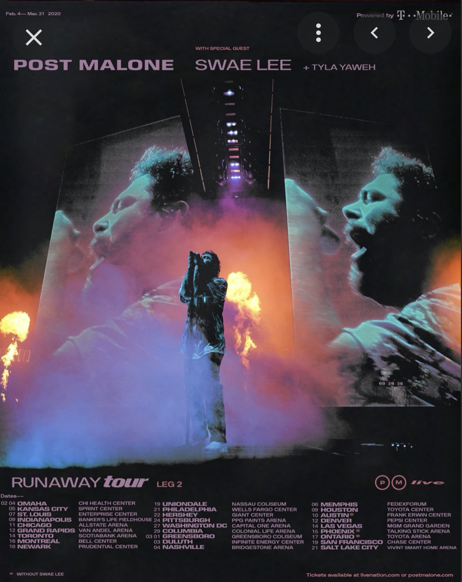

On this poster I like the layout. The tour dates at the bottom and leaves a lot of space for the design for the main space for Post Malones picture. I love the colours on this poster as well as the angle the picture has been taken with the big screens in the background.

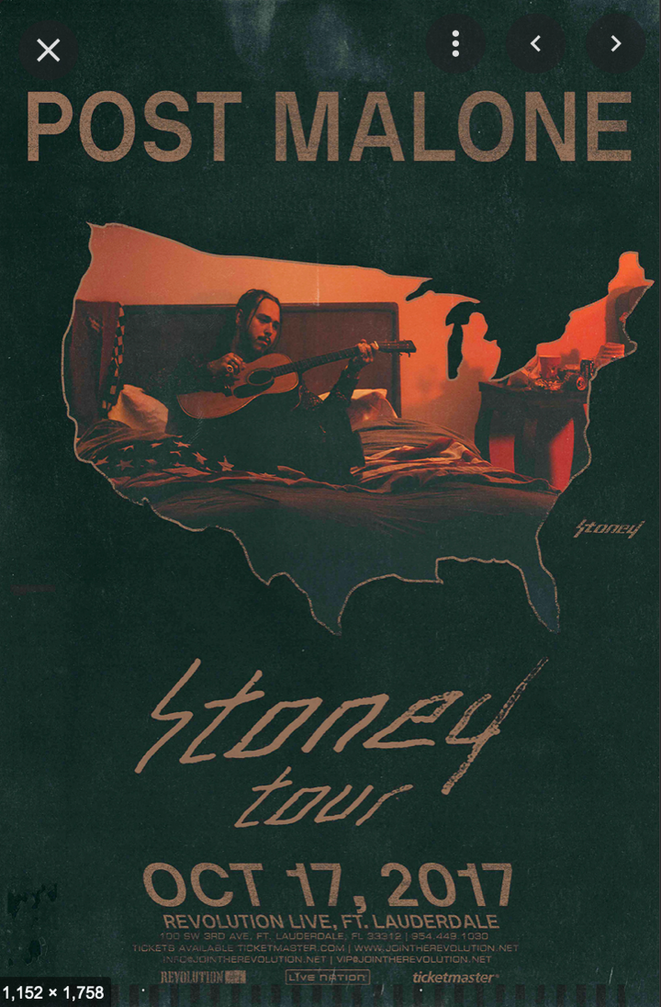

I like this poster because of the colour scheme. The orange and dark green which matches the album artwork. It’s a good concept with the America cut out with Post Malone playing the guitar in his room.

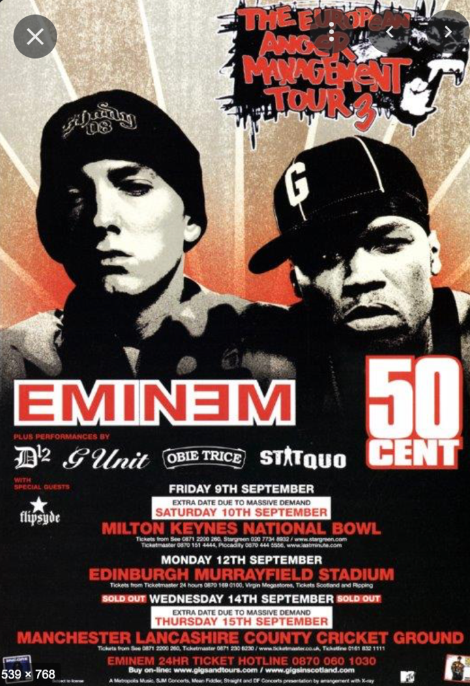

I like this poster because of the ‘old school’ feel to it. It’s simple yet the design is eye catching. The tour dates and location take up a lot of space.

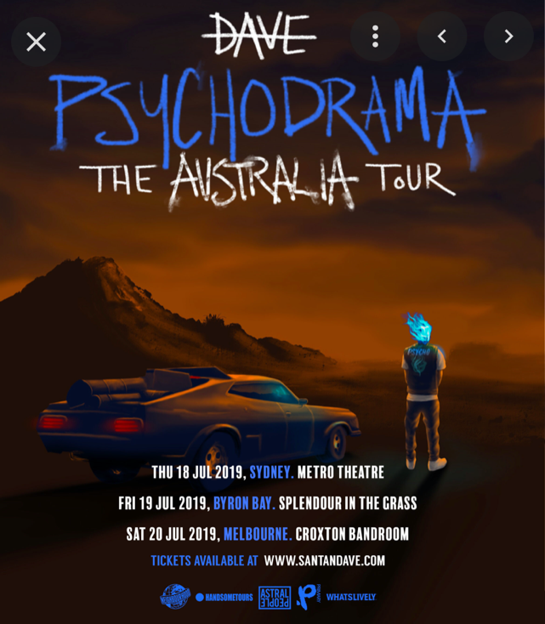

I like this poster as it’s a different version of Dave’s Psychodrama tour for his album. I love the saturated orange with the colour blue font. The car and the figure of Dave add to the aesthetic and vibe of the poster.

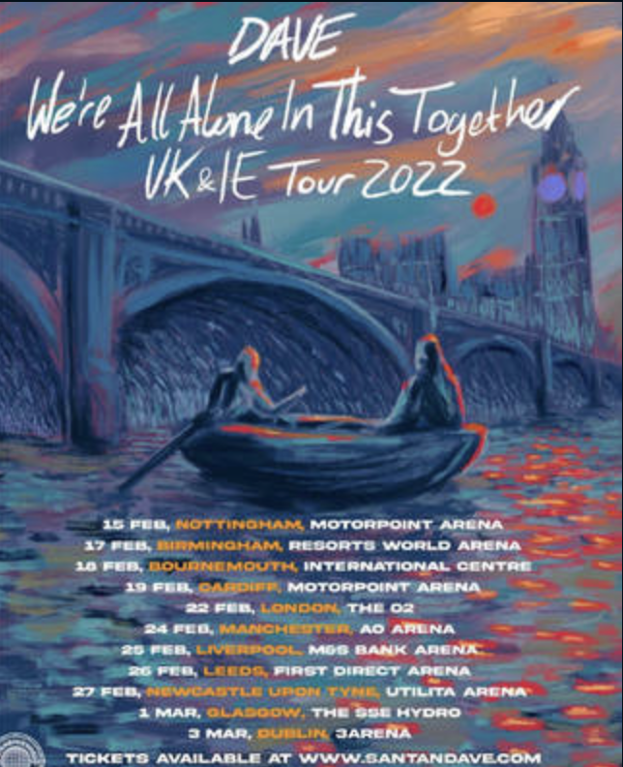

I like this poster because of the colour scheme and the difference to the actual album cover that the tour it is for. The boat in the middle represents the name and the actual album along with big ben in the background.