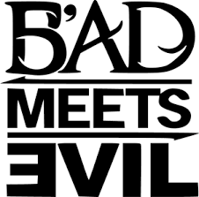

I like this logo as its quite simple yet has some features.

The backwards “E” is a reference to Eminem and is own logo.

The “B” if you look closely has a ‘5’ in it which is a reference to Royce da 5’9 who is the other half of the “band”.

The logo as a whole is saying Royce meets Eminem.

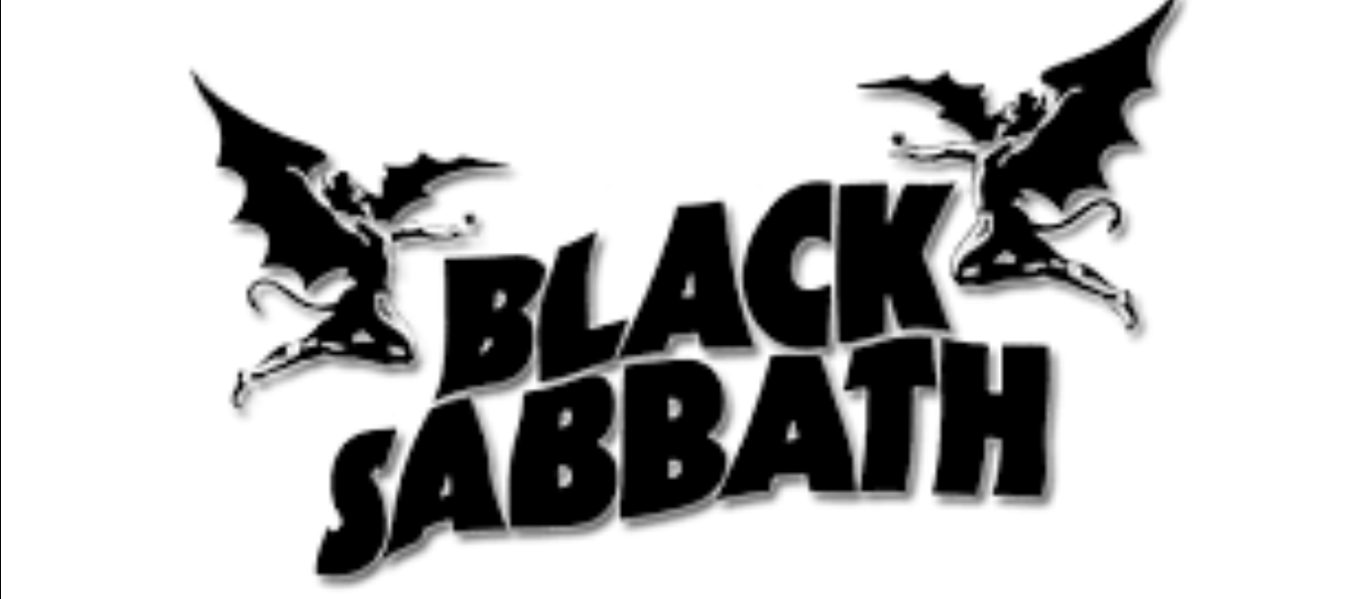

I like this logo as again its simple yet eye catching. The humans with ‘bat’ wings have a reference to the bands dark rock vibe and to Ozzy Osbournes persona.

Band logos in my opinion shouldn’t be overly extravagant but they should be simple yet eye catching. They should have some inner details that people need to look at twice or more to see.

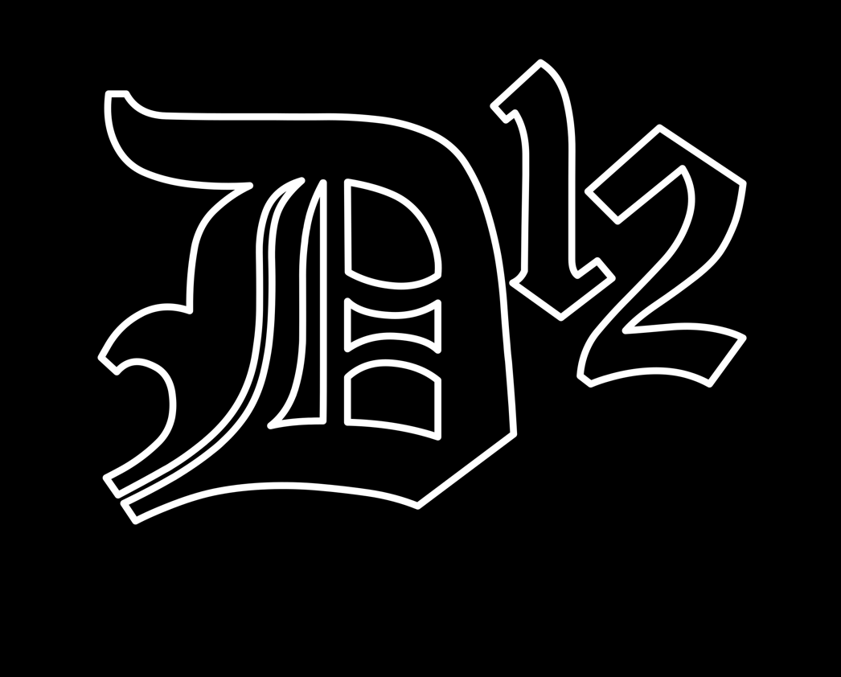

This logo is very simple but the font and black and white makes it interesting.

D12 stands for dirty dozen and was formed in Detroit

I think the logo could do with a few different designs and maybe some with colour.

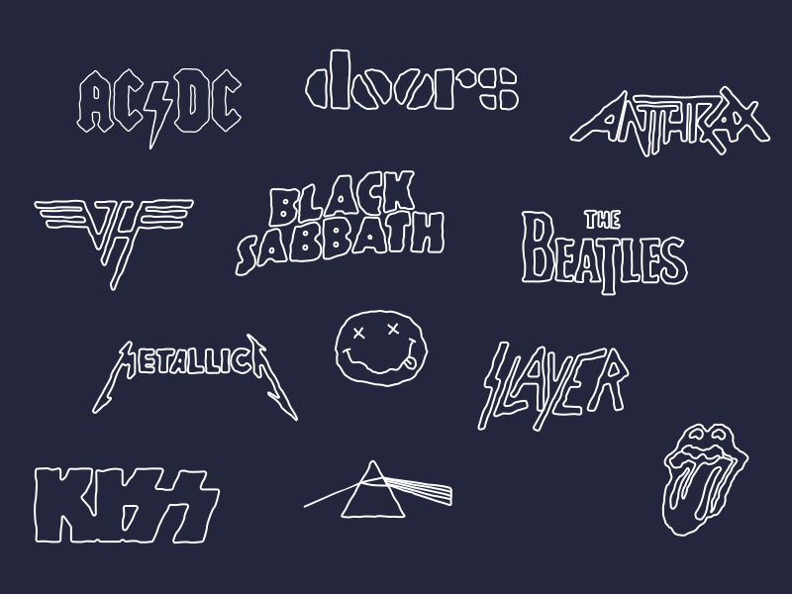

These band logos to me look quite simple yet they’re iconic. Especially the nirvana logo. The face with the cross eyes has

become world famous.