Source:

<https://blog.gocollect.com/concert-poster-collecting-guide/the-history-of-concert-posters/>

In the 1980s, silkscreen prints produced by artists such as Frank Kozik gained popularity. This led to screen printing becoming the most prominent form of poster. Kozik is often credited with reviving concert posters as an art form. He began in Austin, Texas. He’d create black and white posters for the city’s underground scene. He later went on to design pieces for bands such as Nirvana and Pearl Jam. In the 1990s, artists such as Chuck Sperry Emek, and Jeff Wood began to dominate the poster scene.

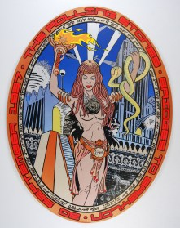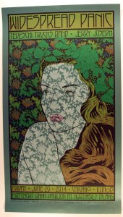

His career began in Columbia in 1989 5 years later he was commissioned to create a poster for a bill graham show. His artwork has been exhibited at leading art institutions including the San Francisco Museum of Modern Art, the Yerba Buena Center for the Arts, and Fort Wayne Museum of Art; his prints have been archived in the collections of the Achenbach Foundation for Graphic Arts, The Oakland Museum of California, The Fort Wayne Museum of Art, San Francisco Public Library (Main Branch), the United States Library of Congress, and the Rock and Roll Hall of Fame