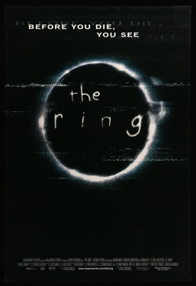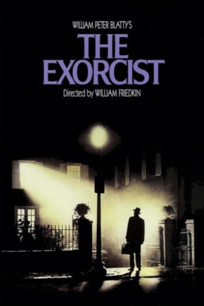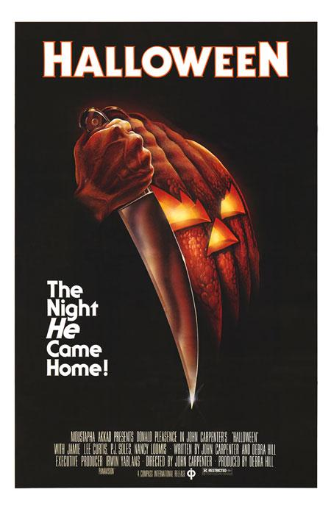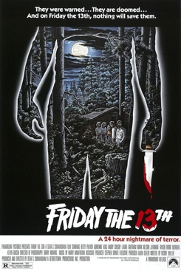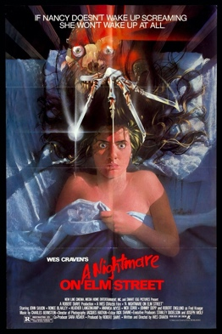 the contrast of darkness and a white ring makes it uneasy also the spacing of the lettering with the static overlay suggest its corrupted and intriguing. The idea of this is give the viewer uneasiness and an intriguing outlook on the film this allows the viewer to differ from watching the film while also wanting to look away.

The use of the finger knives above Nancy’s head suggest that something is manipulating her and causing nightmares. The blood red writing in a nightmare suggest that the antagonist is a killer and the setting off the bed gives the viewer a false sense of security.

The start of the cabin in the woods genre the lettering of Friday the 13th is almost like paint and the bloody knife gives with a glowing outline also gives a whodunnit vibe as well as a killer who could be suggested as supernatural.

The reflection in the knife suggest that is the victim of a brutal attack and the pumpkin is a mask the detail of the little glint of light from the end of the knife shows it’s a sharpened one and the pumpkin looks like a face which has been angered the idea is to strike fear into the audience on the scariest night of all.

The dark background and the one night shining through the window foreshadows the main setting of the film and one of the most iconic scenes the priest looking up makes it seem as though he’s looking towards the heavens the lettering makes it feel very biblical. During the filming of this films there was 9 deaths of cast members , and producers.