Survey summary and Interpretation

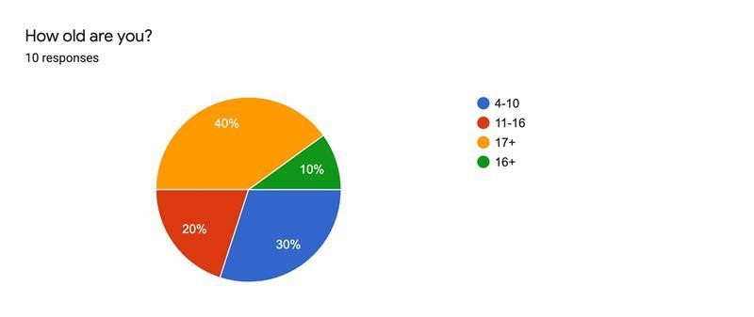

Looking at the chart it clearly shows that there was more 17+ and 4 to 10 years old. As a production team we decided to make Florida’s book to both audiences because we wanted to engage both audiences. Cartoon animations is watched by anyone because it includes comedy.

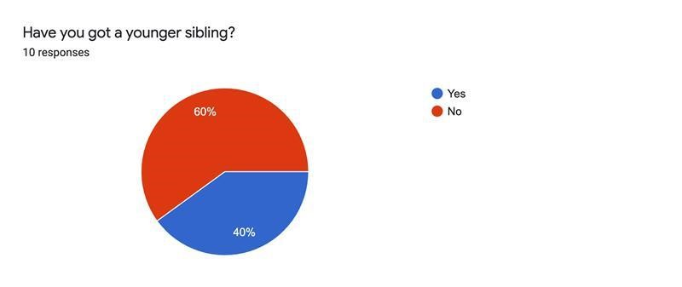

The chart shows most people don’t have younger siblings.
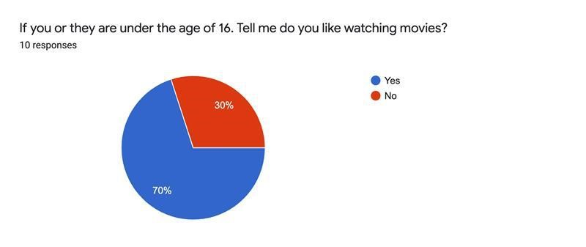

Most contributors would rather watch movies, looking at this, my team and I decided to make Florida’s book seem into a short film. Florida’s book is a cartoon animation film, she faces problems but she fights her fear through imagination.
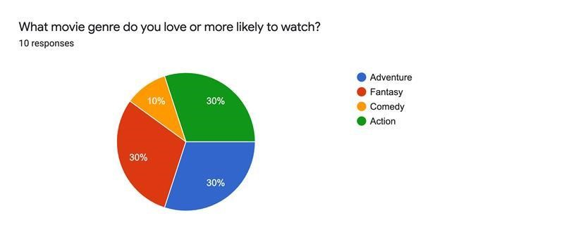

Adventure, fantasy and Action was a tie. Most people are likely to watch Florida’s book as it includes all three.

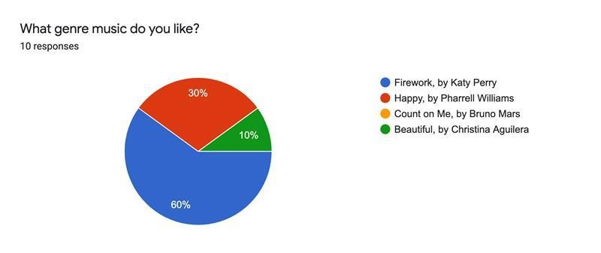

Most people had chosen Firework by Katy perry, so we tried to find a background sound to be used in Florida’s book.

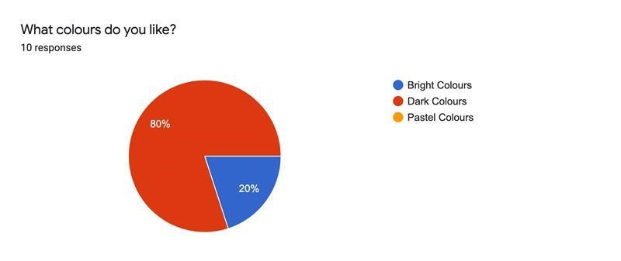
Most people chose dark colours over bright colours, so to meet those requirements we ensured that the colours used in Florida’s book were not too bright as most majority didn’t like. However, we didn’t completely use dark colours as our short film was aimed at children.

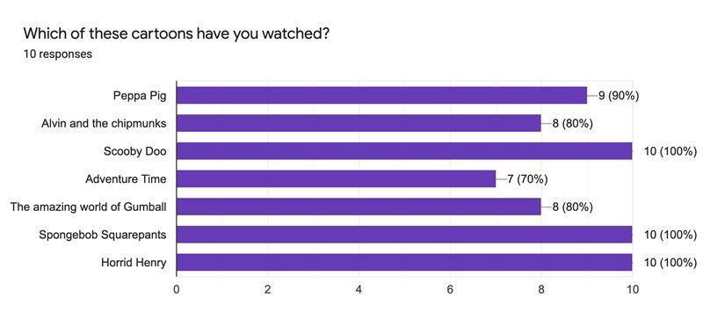

The most watched cartoons were Scooby Doo, SpongeBob SquarePants and Horrid Henry. All these cartoons have a lot in common, they all are highly entertaining and have adventures. For example, Horrid Henry involves a lot in comedy and Adventures when Henry uses his imagination to turn into wild animals to scare his little brother.

