Haafsah Khan
FMP
My reflective Journal

16/03/2022// Today as a team we have finished the pitch and made sure we have all our project proposal finished and uploaded on our digital spaces. We are practicing drawings and planning how to make a flip book.

28/03/2022 // We realised making a flip book, but this wouldn’t really relate to our course of media but more to the art. So, my team and I decided to make a short film including gifs, this would show our filming and graphic design skills. We changed our ideas of how we are going to present to our audience by using CBBC as reference. https://youtu.be/AMoSTMw_L1o

The main ideas are that there will be a voiceover and with that there will be animated gifs that will be shown.

13/04/2022// Us as a team faced many problems trying to focus without communicating. But when I stressed the fact, we need to work as a team we all understood that we need to communicate and take our own responsibilities to complete different areas of this project, so we don’t need catching up every week.
So, this week we made sure that I have completed the:
- Audience Profile
- Character Profile
- Recording Schedule
- Story Telling narrative

Hirah has completed the:

- Shooting schedule
- Reece Report
- Shot List
- Shooting script

Malaika has completed the:
- Level 3 Treatment
- Role
- Storyboard
- Script

23/04/2022 // Malaika started putting making animations using illustrator adobe app. Whilst Hirah and I did the audience profile and planning the shooting schedule.

Meanwhile Hirah then started check listing if we were up to date, we had then found out that we were 2 days behind with the production schedule.

To overcome this problem, we are going to look at how we are going to plan out each role and checklist it at the minute and I have decided to look and stay more in the film department and not get in there way so they more focused and not too reliant on me.

06/05/2022 // Today we are checking if our Digital space is all up to date. Finishing and editing the animations. I'm hoping to book out the cameras and seek permission today to be able to film in the Bradford college greenhouse.

Meanwhile, Malaika is making sure her animated characters are all ready to be gifs and is collecting evidence of work to put on digital space to be accessed. Haafsah is making the poster for our short film.

As I had referred in my project proposal that we will be having a day to day check off list and day to day catch up routine. We are up to date. We have planned our next week for shooting our film.

06/05/2022 We are learning how to make our animations into gifs. We hope to continue production by next week.

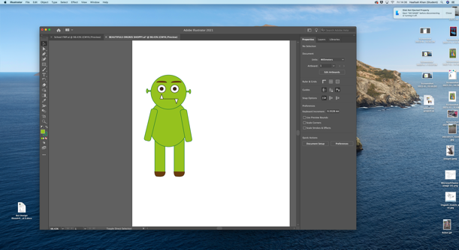
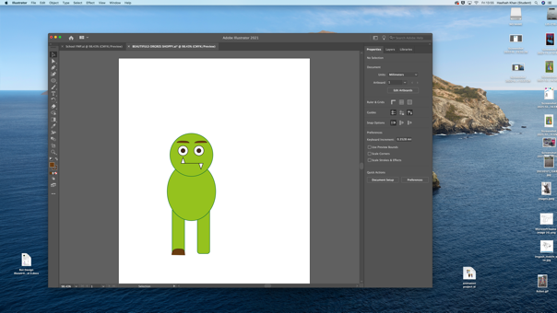

11/05/2022 Yesterday evening Hirah had messaged Steph on teams asking if we could use one of the students from performing arts to narrate for us for our short film. Due to no reply, Hirah solicited one of her friends to narrate for our film. Hirah then booked the cameras.

Wednesday morning, we went to Jakes lesson. Everyone in the class did peer assessment for each other. We realised the script for our short film could have been better. We then edited our script and changed it to make it more suitable for children, as our aim is 4 to 8 years old.

After that we quickly head to the library to take out kids book to use in our film. We then came back to college and asked Paul if he could give us access to the greenhouse. We then found out that the greenhouse turned into an office so therefore we had to find another place to film.

We needed to quickly find a new place to film because our narrator needed to go by 3. The time was 1:45pm so we had less time, which made it more stressful. We then used the photography studio. They had a living room stage which we used.

We then got a good few shot of the scene and we uploaded them on the computer. We are hoping to do editing by Thursday and Friday.

12/05/2022 Today Hirahs finishing the intro for the short film. We all made sure our work was uploaded to Digital Space.

