Poster 1 – Moonlight

The colours on this poster all represent different ideas. Blue represents calm, purple represents mystery and dark blue represents danger. This character could have different personality’s depending on the light of the moon. The colours make the poster more interesting and eye catching for the audience to watch.

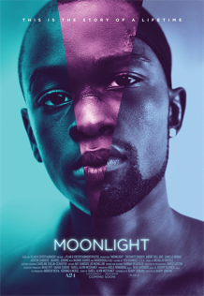

Poster 2 – Jaws

The jaws infer to the shark’s teeth. The idea is that the girl is swimming in the sea and theirs a shark under her, this could represent danger and fear. The title is in capitals and the colour is red this could represent warning.

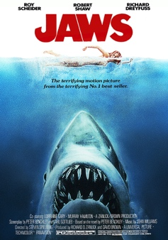

Poster 3 – Battlefield

The idea of this film poster is war related because the background has fire and helicopters. The main character must be standing on the battlefield and therefore he is being surrounded by the soldiers.



Poster 4 – Us

The idea of this film is 2 people in 1 person. The woman has her real face, which shows she’s terrified and then she has a mask of herself which has a happy and pretty face. This represents she’s facing problems and she’s frightened.

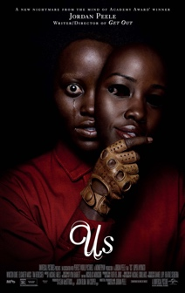

Poster 5 – An inspector calls

The idea of this film is that the people in the background are being inspected by the inspector in the middle. The movie type is a mystery as the inspector inspects the family over a girl that killed herself. The background is a blue colour which represents justice. The way the characters are dressed they look like a wealthy family.

