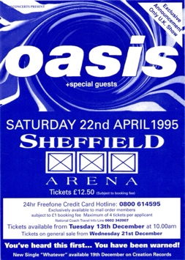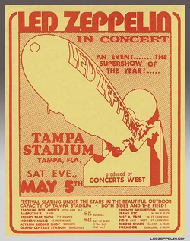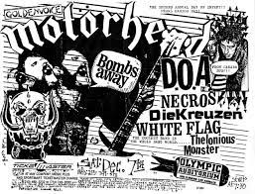

I like this flyer because the detail is very cool and it tells you what you need to know and also has a QR code for easier access to tickets and more information.

I like this flyer because it has the iconic blimp from Led Zeppelin I and also it has quite a variety of information so you know what you need to know.

I like this flyer because it has the black and white colour scheme and you can see Lemmy and the motorhead logo and it has a ton of information.

I like this flyer because it’s incredibly simple and it tells you the most important information as well as having the it’s catching up album artwork as the background.

I like this flyer because I like the fully turquoise colour scheme as well as the simplicity of the design and information.

I like this flyer because the blue and white colour scheme is quite cool and eye catching, also is has a lot of information including a promotion of a new single.