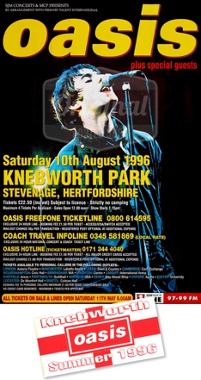I like this poster because of how iconic it is and it tells you what you need to know about the gig/tour.

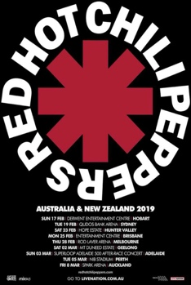

I like this poster because of how simple it is and it has the band logo presented big and tells you what you need to know about the gig/tour.

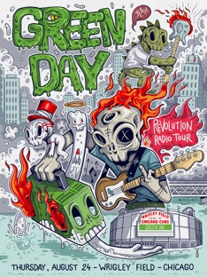

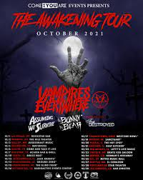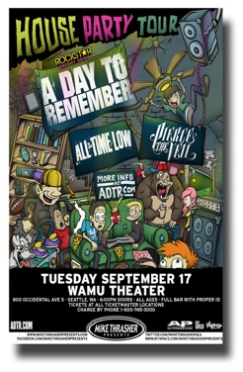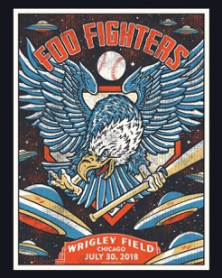I like this poster because it is very cool and has a great design with great detail and it has a huge presence and eye-catching features.

I like this poster because it is very simple and is very unique to this specific show so it makes sense.

I like this poster because it is really cool and has a great design with great detail and it has a huge presence and eye-catching features. Also the imagery fits perfectly with the name of the gig/tour.

I like this poster because it has a dark and eerie aurora and fits perfectly with the style of music and the time it was made as well as just looking really cool.