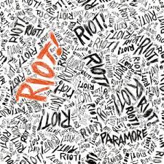I like this typography because its probably one of the most meaning full albums to me and its iconic to the early 2000s.

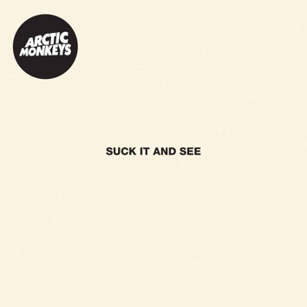

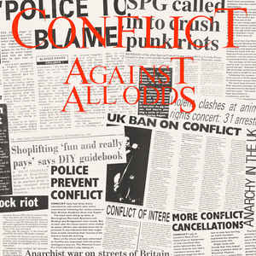I like the typography because its probably the simplest cover I’ve ever seen and it still works and looks very good.

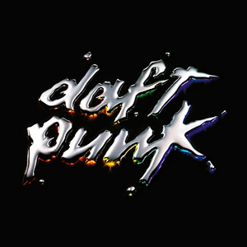

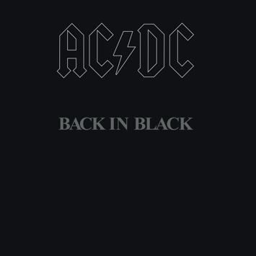I like the typography because it’s very cool with the main silver and the red,orange,green and blue behind it.

I like the typography because it’s one of the most iconic rock albums ever and I love how it’s just black and nothing else.

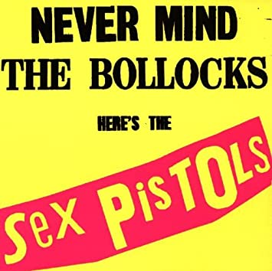

I like the typography because it has the album name in black and the band name in red with the yellow background and I like the chemistry between them all.

I like the typography because I love how it uses the newspaper as background typography and then it has the main typography in red which blends well together.