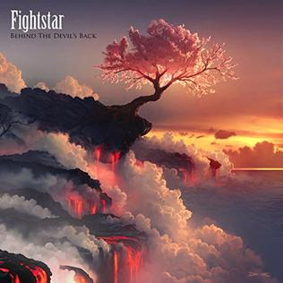I like this album cover because of how beautiful it is with the pink tree and the lava falling past the clouds.

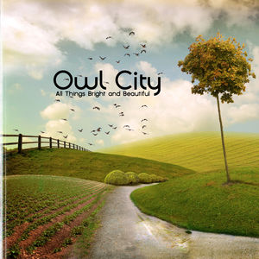

I like this album cover because of how bright and beautiful it is and also how natural and calm it is.

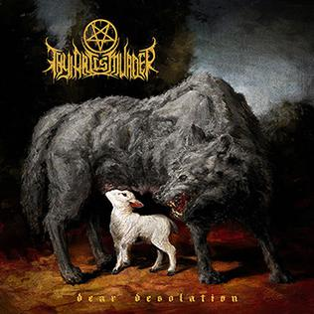

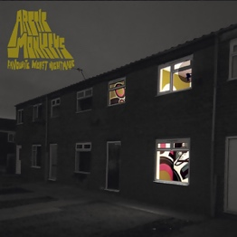I like this album cover because of how dark and evil it is with the wolf and the innocent lamb.

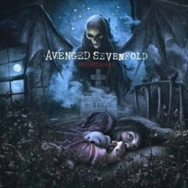I like this album cover because of how mysterious it looks with the one house with its lights on and the interior of the house.

I like this album cover not just for the look of it but for the meaning of it as the little child at the bottom symbolises the rev who was the bands drummer who died.

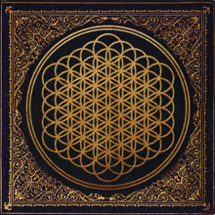

I like this album cover because of the design and the colour combination of the black and gold.

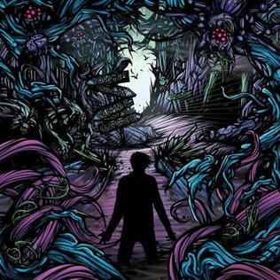

I like this album cover because of how complex and unique it is with the purple and blue.

I like this album cover because of the way Jack Black and Kyle Gass and Beelzeboss are trying to reach for the Pick of Destiny in the clouds.