Look through your project so far and give examples of where you have shown evidence for the following. If you have no evidence for any of these areas, note down how you will gather sufficient evidence for these.
LO1 Investigate the materials associated with a specialist industry practice
How have you investigated materials used within your specialist industry practice?
How have you shown how to select, manipulate and combine materials to create desired results.

I have not used any materials in my specialist industry practise. Since I am doing digital illustration for this project. My specialist industry practise is digital illustration. The application I use in most of my works would be Photoshop and I’ve learnt many skills from testing many of the tools in my work like e.g. I’ve learnt to add effects to the background, learnt how to use the gradient tool for characters or the background and I’ve learnt to layer/combine other work on top of each other like a puzzle so everything fits perfectly.
LO2 Investigate the technical skills associated with a specialist industry practice
How have you investigated the technical skills used in your specialist industry practice
How have you discussed the pros, cons and limitations of the technical skills within your specialist industry practice.
What technical skills have you selected, manipulated or combined and how has it created the desired results.
How have you investigated other sources of technical skills development?
The technical skills that are associated is illustration and learning how to draw digitally.
• So far, the skills I have acquired during this project is that I’ve learnt that I could use the smudge tool to make an animal that I’ve drawn have fur.

I’ve also played with the opacity so that I could make like a ghost character or if I’ve added two characters, I could have added more focus to a specific character by making them translucent
• The pros of my specialist practise are that that I don’t have to draw on paper and I prefer to draw on a laptop or tablet
• The second pro is that I’m still learning more technical skills since I’m not “technical savvy”
• The cons are that I do make a lot of minor mistakes like not saving work properly, forgetting where it is saved and thinking of what I should add while doing the work
• Another con is sometimes figuring if something should be changed about the work and I find it hard to make my own character and rely on references

LO3 Investigate creative processes associated with a specialist industry practice
How have you considered what other practitioners with your specialist industry practice do?
How have you measured the effectiveness of other practitioners creative process and how have you used this in your own work.
LO4 Solve problems within a specialist industry practice
Have you considered the problems that are likely to occur within your specialist practice.
How have gone about pre-empting and solving these problems (Practical, Technical, Theoretical and Conceptual)
Have you considered how other people have solved similar problems?
How have you assessed and documented the impact of your solutions on your creative intentions?
I have run into lot of technical problems whilst drawing like e.g., the paint brush tool doesn’t show up on a certain layer
I solved the problem by going up each layer gradually testing each layer to see if the paint brush tool was working
Another problem I’ve had was when an area was high-lighted and I wanted to use the paint bucket tool or the gradient tool it wouldn’t show or the entire page was coloured instead
I would have solved this by trying it on a new layer or resetting my work .

I haven’t considered how other people would fix these problems but I’m guessing they would think of another way.

LO5 Use safe working practices with a specialist creative environment
How have you used safe working practices within your specialist practice environment.
What risk assessments have you completed and how has this managed, reduced or eliminated risk in your specialist practice environment?
LO6 Use specialist industry practice presentation techniques to present your work
How have you considered the pros, cons, uses or limitations of different presentation techniques used in your specialist industry practice?
How have you considered this in terms of costing, skills, tools needed, format of presentation (digital, physical) and how practitioners in your specialist industry practice display their work?
Have you considered and discussed brief related influences on your presentation choice?
- The pros of doing digital art is I can do effects in my work and size I can make my character/s any size, I can bring character/s forward or backward on the page, play with the opacity duplicate images, turn images vertically/horizontally and I could fill a page with any colour by using the paint bucket tool.

- The con of doing digital art is not saving work properly , forgetting where it is saved , misplacing it , software issues and changing your mind when doing your work.

- My limitations are that I haven’t learned every thing I need to know about photoshop and that my digital skills are very limited.

Tools I have used on my final pieces
- Paint bucket- background/foreground and characters
- Gradient tool- background/foreground and characters
- Paint brush- drawing fox
- Free transform-enlarging or shrinking images or characters
- Duplicating layer/s-stacking layers
- Ellipses tool-the nose
- Smudge tool- fur
- Lasso tool/polygonal- foxes



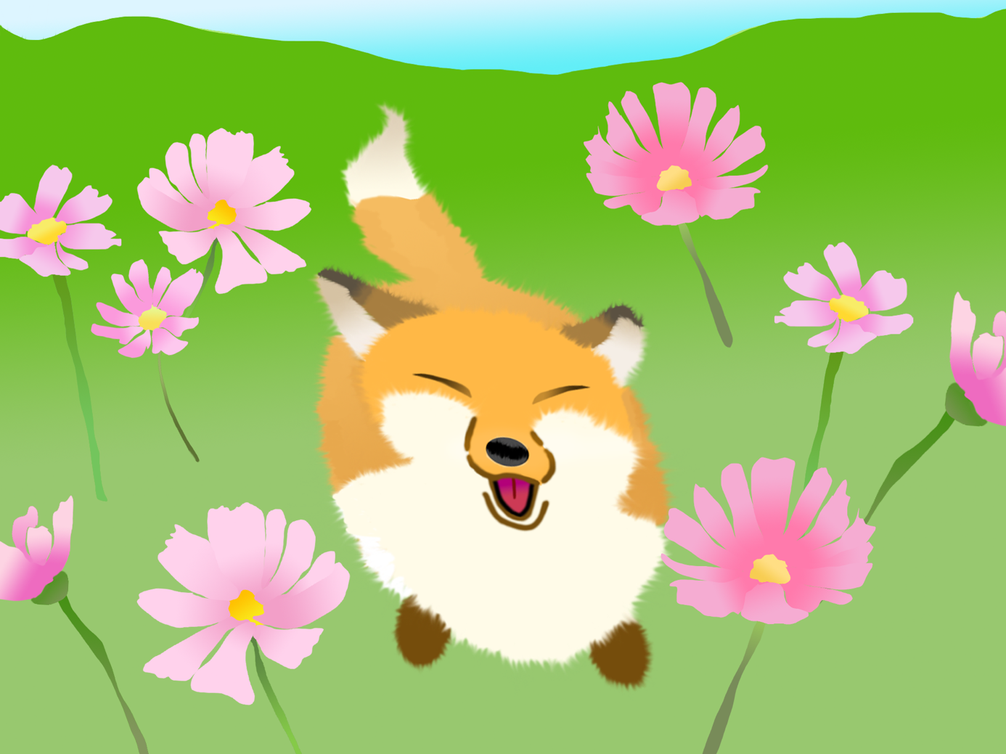


Satisfactory | Valid  Clear  Professional  Relevant  Satisfactory  Clear  Appropriately  Sufficient | This guide indicates the language used to describe each grade level.  Whilst looking through your own work, read these descriptors and consider which level the evidence of your work fits in.
Good | Valid  Clear  Professional  Relevant  Satisfactory  Clear  Appropriately  Sufficient | Purposeful  Extensive  Adept  Developed  Considered  Effectively  Reasoned
Excellent | Valid  Clear  Professional  Relevant  Satisfactory  Clear  Appropriately  Sufficient | Purposeful  Extensive  Adept  Developed  Considered  Effectively  Reasoned | Innovative  Imaginative  Comprehensive  Confident  Sophisticated  Decisive  Sustained  Perceptive  Insightful  skilfully
Unsatisfactory | Not valid  Insufficient  Unprofessional  Inappropriate  Unclear  Not relevant  Lacking competence  unsatisfactory

