FMP proposal: UK rap, a grimy world

The main concept of my final major project is to showcase the Uk rap scene and the many forms that have been created over the years as well as to the struggles and backlash faced throughout. I plan to do this through a short series of radio show style podcasts with a run time of around 10 mins per episode for easy to digest content. I feel this is fitting given the importance of radio shows and stations within the early days of the genre and it's still an important cornerstone of the genre to this day. I plan to record audio and visuals for this which will be edited using premiere pro to get the best experience for my audience, however I would like to keep cuts to a minimum to keep a raw and authentic feel to it. Additionally, I would like to add pop up visuals with trivia or extra context using Adobe photoshop and after effects as a way to keep retention and engagement high throughout the episodes but again keeping it subtle to avoid losing the natural feeling of it. I will try to keep a relatively fast pace to be able to cut up the podcasts into more short forms of content (Instagram reels, TikTok and YouTube shorts) which in turn should help to improve discoverability and reach so my work is viewed by larger audiences.

One of the main reasons I've chosen to pursue this topic for my project is the current perception of grime and drill (Uk rap subgenres) is in a rather negative point with people often citing it as inspiration and motive for violent crime rates rising within the Uk. I feel this is greatly unfair to the artists and fans alike and would like to make the aim of my project to try shift people's views regarding the genre to a much more positive mindset.

Another reason I have chosen to highlight this industry and genre is due to the Uk governments repeated attempts at blocking and censoring the music and its artists. This I feel is an incredibly duplicitous manoeuvre by the government by moving to blame the artists for crime pertaining to violence and drugs instead of addressing the issues brought up by the artists which are impactful on a socio-economic level caused by said governments policies and reforms. I would like to be able to enlighten a new audience to the many struggles the grime garage and drill genres faced to even be able to make and distribute music and the repeated oppression of these communities by the law makers and power holders.

In conclusion my main aims and purposes of my final major project are to showcase the talents, stories and struggles of the Uk's rap scene. I aim to do this through a series of short radio show style solo podcasts and short form content will be taken from these to target exposure and growth in multiple ways.

Proposed research sources:

# **The Police vs Grime Music - A Noisey Film**

[The Police vs Grime Music - A Noisey Film](https://youtu.be/eW_iujPQpys)

[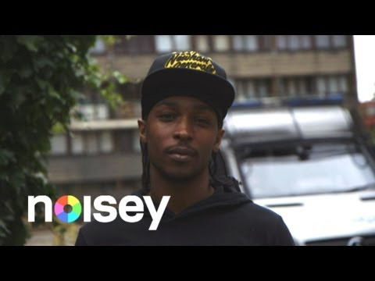](https://youtu.be/eW_iujPQpys)

# **"Once Upon A Time In North London” - a film about Tottenham featuring Skepta, Wretch 32 and Avelino**

["Once Upon A Time In North London” - a film about Tottenham featuring Skepta, Wretch 32 and Avelino](https://youtu.be/JTRXUCw3kaM)

[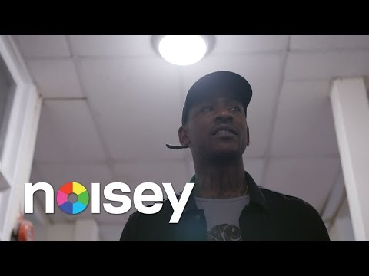](https://youtu.be/JTRXUCw3kaM)

# **Don’t Call It Road Rap - A Noisey Film (Full Length)**

[Don’t Call It Road Rap - A Noisey Film (Full Length)](https://youtu.be/xn-70oSrLgA)

[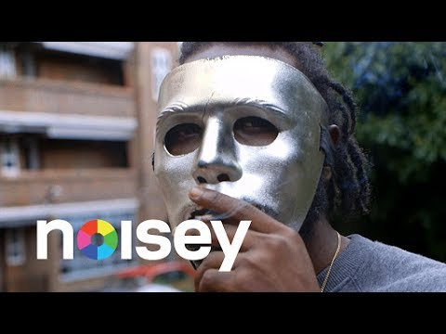](https://youtu.be/xn-70oSrLgA)