Candidate Authentication form
This declaration must be completed and signed by the student and countersigned by the tutor or assessor.

Guidance for candidate
You have been asked to sign this Candidate Authentication form and place it at the front of your portfolio. It confirms that the work you have submitted for assessment is your own and that you have not copied it from someone else or allowed another candidate to copy from you.

Candidate declaration
I confirm that the attached portfolio is all my own work* and does not include any work completed by anyone other than myself.
Qualification title: | UAL Level 3 Extended Diploma in Performing and Production Arts
Candidate’s full name: | Alexander Stewart Hammond
Candidate’s signature: | 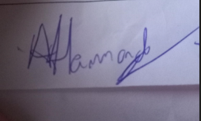 | Date: | 31.10.22

*unless otherwise stated, candidates can work together but should show sections which are their own work.

UAL Awarding Body is collecting images of students’ work for its online gallery and for use in materials to help teach this qualification to other students. This will largely happen via our website but we may also use some images in our printed publications such as the course specification for this qualification.

Approval for use of own work
Should we identify your work for use in this way, we would be very grateful if you would allow us to photograph it.

If you are happy for us to use images of your work in this way, then please sign below:
Print name: Alexander Hammond | Candidate signature: 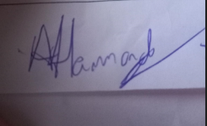

Centre confirmation of authenticity
On behalf of (insert centre name) alexander hammond , I confirm that the above mentioned candidate, to the best of my knowledge, is the sole author of the completed assignment/portfolio attached and the assessments have been completed under the required conditions.

Tutor or assessor declaration
I confirm that, in line with the requirements of the course and the quality procedures operated by the centre, all reasonable steps have been taken to monitor the authenticity of students’ work for this assessment session.

Print name: | Sara Sutton
Signature: | 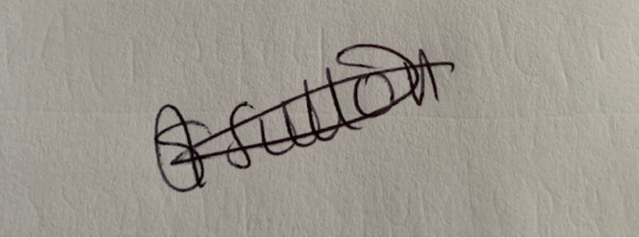
Date: | 31.10.22

