**Fantasy:**

This is a genre of literature that has magical and supernature themes that do not exist in the real world. For example, Harry Potter, Percy Jackson, Supernatural and Luca are all fantasy movies. The fantasy genre uses creature such as fae, elves, trolls, dragons, kitsune, chimera, banshee and hydra.

<https://www.google.com/search?q=creepy+mythical+creature&source=lmns&bih=1361&biw=2560&safe=active&hl=en&sa=X&ved=2ahUKEwiYgfL7npLzAhUIyRoKHdsyB3UQ_AUoAHoECAEQAA>

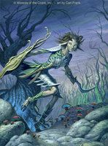Fae;

Stories about the fae do not have a clear origin and are a collection of folklore from multiple sources. Faerie are described as magical creatures with human appearances and a penchant for trickery.

<https://en.wikipedia.org/wiki/Fairy>

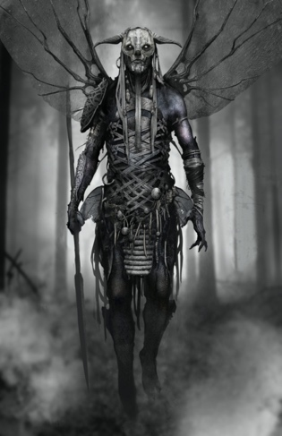Elves

Elves come from Germanic folklore in the medieval time and thought to have magical powers and supernatural beauty. They are capable of both helping or hindering people.

<https://en.wikipedia.org/wiki/Elf>

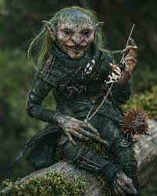Trolls

Trolls are derived from Scandinavian folklore and Norse mythology. They are said to live in rocks, mountains and caves, they live in small family units and are rarely helpful to humans.

<https://en.wikipedia.org/wiki/Troll>

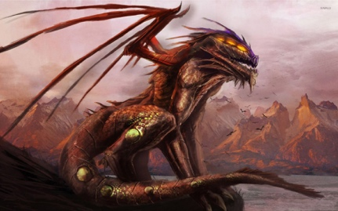Dragons

Dragons a large reptilian creature from many different cultural folklores. Dragons are often seen as hybrids of feline, avian and reptilian features that can often times breathe fire.

<https://en.wikipedia.org/wiki/Dragon>

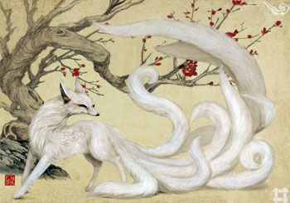Kitsune

Kitsune are intelligent foxes that possess paranormal abilities that come from Japanese folklore. Some stories say the kitsune use their powers to trick others while other portray them as faithful guardians.

<https://en.wikipedia.org/wiki/Kitsune>

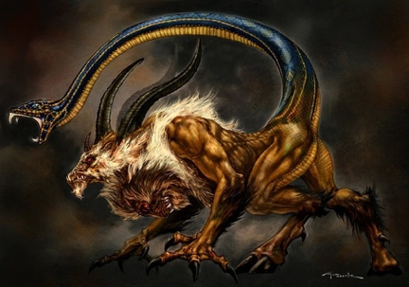Chimera

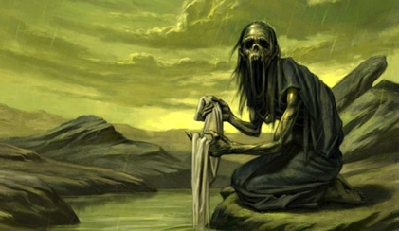Banshee

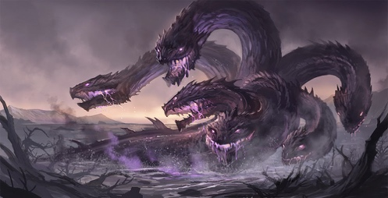Hydra