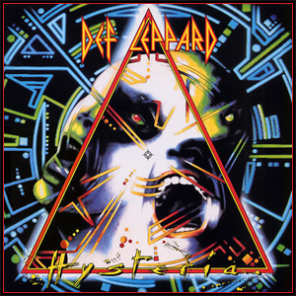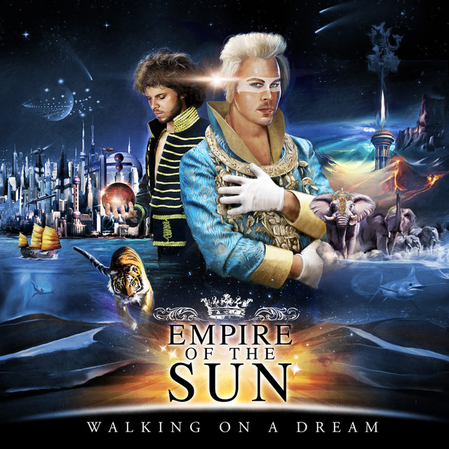

I chose these two albums covers due to the complexity of the design walking on a dream especially because of the background, its unnecessarily detailed which makes for a capturing image, hysteria also has a lot going on, very geometric and uses of different fonts, both have use of lots of colours, and in most cases makes you want to keep looking.

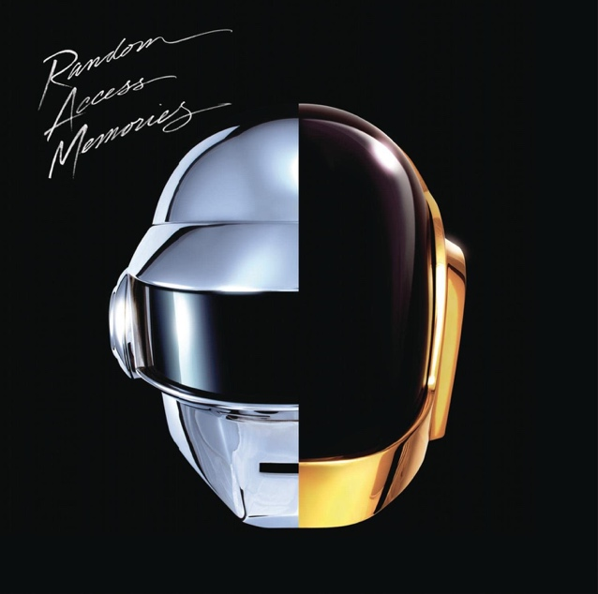

This one for simplicity, contrast to the album is very complex as well as one of my favourites.

I chose 2 daft punk albums, this one because I like the font, it looks like poured mercury, and overall is a simple but effective design.

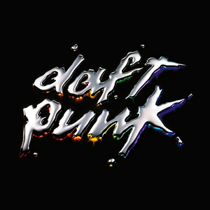

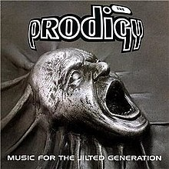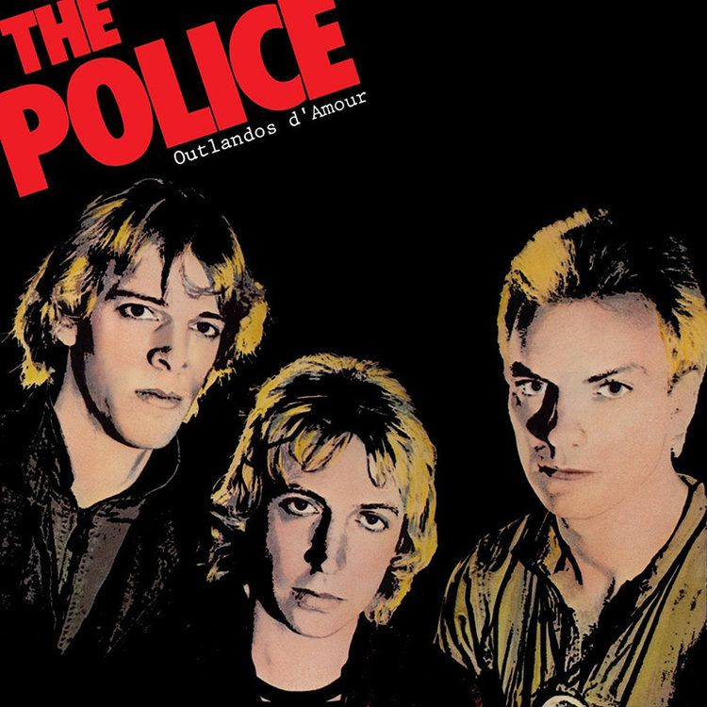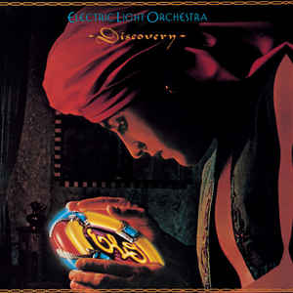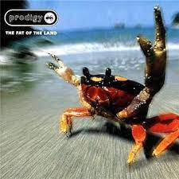

This album cover used to scare me when I was little, which shows designs do have an impact on emotion.

Yet again simplicity, the font is basic and bold and just consists of the band members

I really like ELO for their use of their logo, as its primarily used as a space ship, but for this one perfect for the album as it’s a discovery.

Another prodigy album cover, again I just like it because it’s very obscure, not really sure why there’s a crab, but it’s cool.