

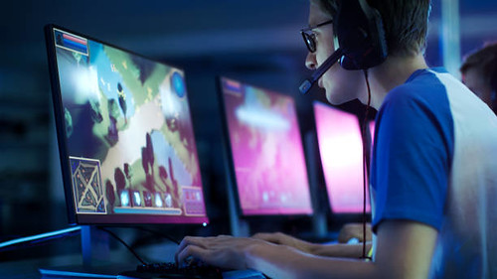

[This Photo](https://www.flickr.com/photos/156259214@N05/43268759392/) by Unknown Author is licensed under [CC BY](https://creativecommons.org/licenses/by/3.0/)

**PARENTS**

This idea would also be good for parents as it is teaching their kids about space. This project would appeal to parents because they could learn about gameplayed by their children and so it could help them get close to their kids.

**Teens Ages 13-18**

My idea is to create a tutorial on a game known as stellaris as for how this is targeted towards teens is because it is teaching them about space in which they might find interesting



[This Photo](https://freepngimg.com/png/27696-parents-transparent-image) by Unknown Author is licensed under [CC BY-NC](https://creativecommons.org/licenses/by-nc/3.0/)

This tutorial will appeal to the demographic of adult gamers because usually adult gamers prefer games which are more strategic. This tutorial will help them keep their brain active and learn the basics of a very complex game

**Tar get**

**Audience**

**POCKET PLANET**

**ANIMATION**