Podcast plan

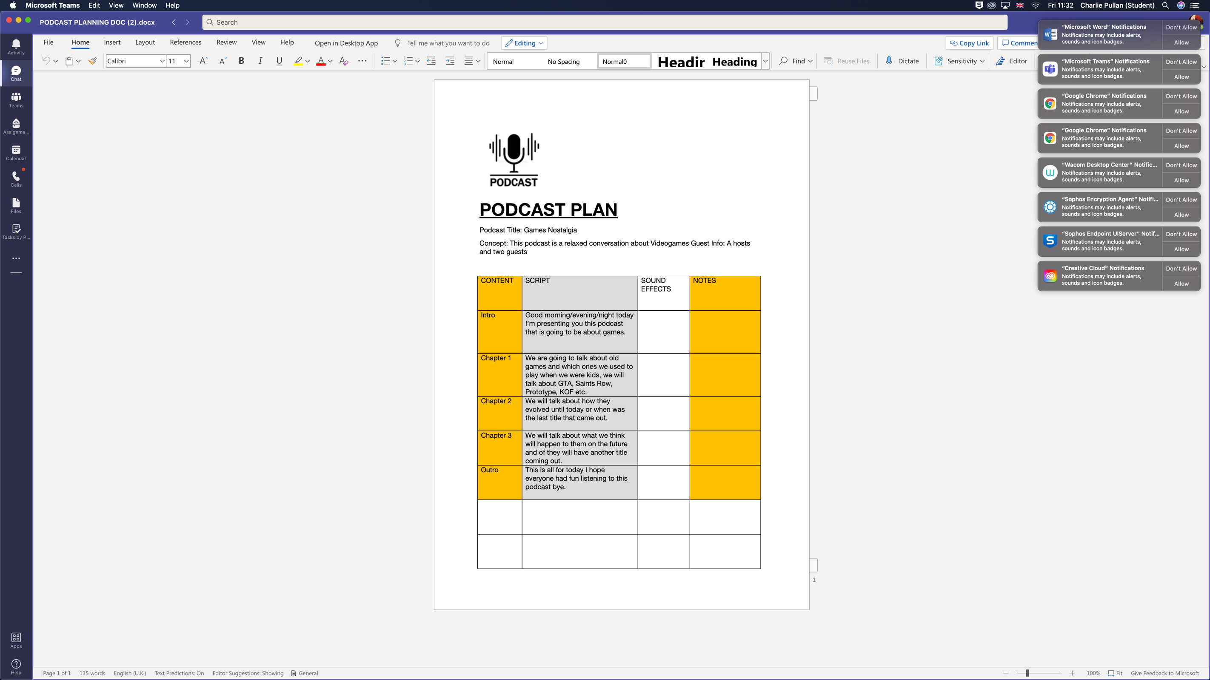

When working on this podcast project I was working with Tayyab. As Tayyab was the presenter he wrote and created our script. This is a screenshot of that script that Tayyab created.

Tayyab’s first question: We are going to talk about old games and which ones we used to play when we were kids, we will talk about GTA, Saints Row, Prototype, KOF etc.

My planned response: my favourite game in that list would have to be saints row or prototype as those have a nostalgia feature for me since I played them as a kid quite a few years ago, they are pretty old games as well since I think that both of them were released in 2009

Tayyab’s second question: We will talk about how they evolved until today or when was the last title that came out

My planned response: I would say that the games evolved pretty well as they were part of people’s childhoods for when they first started playing video games the sad part mostly is that the companies that have made the games have sadly stopped making them since the last prototype title was back in 2012 and I don’t think they have the money to make another game

Tayyab’s Third question: We will talk about what we think will happen to them in the future and if the will have another tittle coming out

My planned response: personally I think that the games will be regarded as classics, I do know of a new saints row game that is coming out but fans don’t really like its nature as it has none of the original characters that were in the old game, as for prototype I don’t think another game of that series will be realised since I am pretty sure the company that made the prototype games went bankrupt but I really do hope that somehow a new prototype game comes out since prototype was my favourite game to play as a kid