Game Design Written Plan Template

This document will help you write up and develop your game design plan. Use it how you see fit. Be sure to add your research into this document there is a bibliography at the bottom to input your hyperlinks to your research.

# GENRE/TYPE/ DESIGN

Here is the perfect space to describe those first important elements of your game.

Genre – sandbox, open world

Type – platform, roguelike

Design – 2D, pixel art

RESEARCH

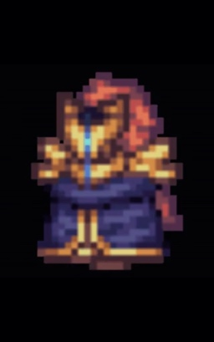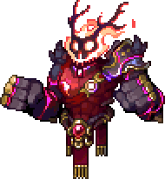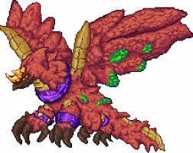

# STORY/PLOT

In the beginning there was a mage called calamitas this mage was mastered in the most powerful magic in the universe also known as brimstone magic. One day her home was attacked and her brothers were killed in a fit of rage she unleashed all of her power onto the armies attacking her home wiping them all out attracting the attention of yharim a powerful king who offered her a deal in which she accepted. She would then proceed to help the king with various tasks in which some had her wipe out entire races until eventually she couldn’t take it anymore and left yharim behind sadly yharim cursed her as she left and as so she had no choice but to return to avoid being killed by the curse. This is where the player comes in getting stronger and stronger until eventually facing yharim in a final battle destroying part of the world with it depending on if you die or not depends on who wins the battle

# CHARACTER LIST

The main character will be the player of course while the npc’s will be The guide, Supreme calamitas,yharim, the arms dealer, the nurse, the merchant, the alchemist, the operator and the cyborg. As for the bosses most of the bosses from the calamity mod for terraria will be in there as well as a few extra bosses including yharim the true final boss

# MISSIONS/TASKS/PROGRESSIONS

In the game you progress by killing bosses, killing certain bosses will drop certain items or make certain events in the world happen that can help your progression to get stronger some of the npc’s can also give you quests usually collection quests such as collecting a certain amount of one item for one of them

# AWARDS/ACHEIVEMENTS/WINNING/END RESULT

You can get awards from killing bosses such as trophies which you can put on a wall to show off what you have done and the end result from killing yharim will be extremely strong weapons in which you can try to use to beat the boss rush which is all of the bosses but with buffed health and defence

# EXTRA ELEMENTS

Certain items will be references to certain games such as borderlands 2 such as a weapon called the conference call which is a gun that will only drop from a certain enemy once killed on the highest difficulty

LEVEL DESIGN

# STEP 1 – BACKGROUNDS

Certain backgrounds will activate once a boss is spawned or whenever in a certain biome such as the pillars which are spawned when killing the lunatic cultist at the dungeon on one side of the map they look like this:

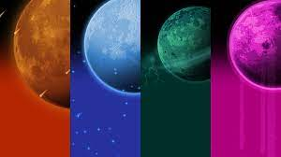

Theres also certain biome based backgrounds such as this: 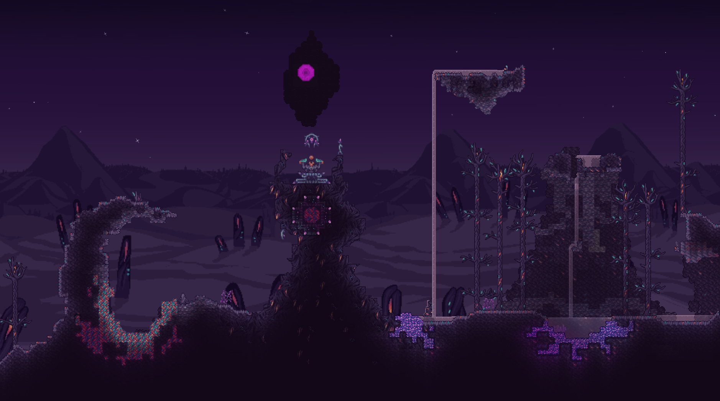

# STEP 2 – START POINT

Your player will start in the middle of the map with an npc called the guide, the guide will assist you in any starting crafting recipes and can provide advice on what to do like a tutorial what you would do to start usually would either be explore to find chests or build houses for additional npc’s

# STEP 3 – END POINT

Your journey will finish once yharim is defeated (extra note during the battle a chunk of the world will be removed as the battle will destroy part of the world) once he is defeated you can craft end game weapons and armour which will be stronger then anything else in the game

# STEP 4 – OBSTACLES

Certain bosses will be quite hard and will require proper planning and a possible building of an arena to fight as you will need a lot of space to move to avoid the projectiles of the boss, as for the dungeon you cannot go down it until skeletron is defeated as attempting to go down before the boss is dead will result in the dungeon guardian spawning causing you to die as it will one shot you

# STEP 5 – NPC’S

Certain npc’s such as the arms dealer will sell you weaponry that can be crafted into certain end game gear when you have the ingredients some npc’s will also require you to do quests for them, also certain npc’s don’t spawn until a certain requirement is met such as a certain boss is defeated

# STEP 6 – PLOT & WHY?

Each boss will drop a lore item in which it will tell you about the boss and the lore behind it once you defeat all the bosses and collect all the lore items you can combine all of them into a book in which it will tell you the full story of the world and how all the bosses came to be

# STEP 7 – MOVEMENT & CONTROL

The game is designed for both pc and controller however you may find it easier on pc. Theres certain items such as master ninja gear which gives you a chance to dodge and attack along with allowing you to dash in a certain direction theres also grapple hooks and wings which allow more movement possibilitys

# STEP 8 – CONCLUSION

People will want to play the game to learn all the lore behind it and to really challenge themselves as there will be a variety of difficulty options one of them being a one hit kill mode which will truly challenge the player so if you want a challenge you can come to this game and get one

BIBLIOGRAPHY

Include links to all your research here, all the websites you’ve looked at, the YouTube clips you’ve watched, even books and bogs you’ve explored, copy and paste the hyperlink below…