Game Design Written Plan Template

This document will help you write up and develop your game design plan. Use it how you see fit. Be sure to add your research into this document there is a bibliography at the bottom to input your hyperlinks to your research.

# GENRE/TYPE/ DESIGN

Here is the perfect space to describe those first important elements of your game.

Genre –guns

Type – fighting, killing

Design

# RESEARCH.

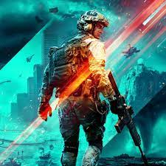

# STORY/PLOT

The story of the game will be how they were the only one alive from the zombie apocalypse and try to survive and help out their team mate

# CHARACTER LIST

There will be 4 characters playing.

# MISSIONS/TASKS/PROGRESSIONS

The mission of the game is to kill the zombie and try not to die the task of the game is to find the gun and the touch light so they can see in the dark also they can use a car to be easy for them to escape the zombie and the dogs

# AWARDS/ACHEIVEMENTS/WINNING/END RESULT

The award would be how many kills they got the end of the game is when they go to another place to fight if they won and didn’t die.

# EXTRA ELEMENTS

LEVEL DESIGN

# STEP 1 – BACKGROUNDS

The background of the game is going to black to be dark

# STEP 2 – START POINT

The start point of the game is them finding the items for them to use

# STEP 3 – END POINT

Once they won they can go to another level of the game

# STEP 4 – OBSTACLES

Zombies will try to kill them

# STEP 5 – NPC’S

# STEP 6 – PLOT & WHY?

The player of the game has to kill the zombies to able to go another level

# STEP 7 – MOVEMENT & CONTROL

# STEP 8 – CONCLUSION

BIBLIOGRAPHY

Include links to all your research here, all the websites you’ve looked at, the YouTube clips you’ve watched, even books and bogs you’ve explored, copy and paste the hyperlink below…