**Research on Mobile Apps**

There are over 4 million apps in the Google Play and Apple App Store combined according to [Statista.com](https://www.statista.com/statistics/276623/number-of-apps-available-in-leading-app-stores/):

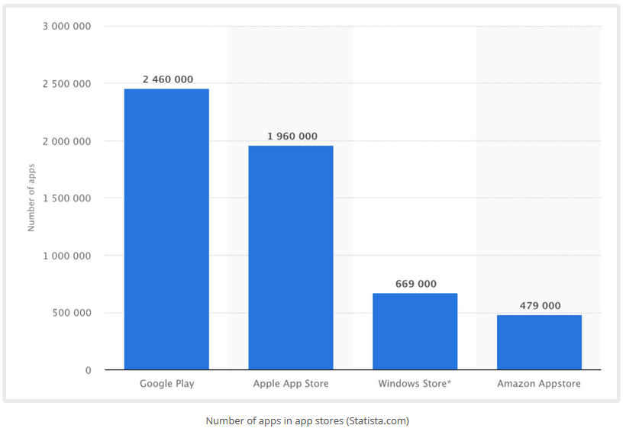

Think of a few apps that you use very often. Is there a way that you could take the most useful features and meld them together to form a new type of app?

Scroll through the ratings and reviews of any competing apps you find. Take note of the following:

* App Name
* Feature set
* Price/monetization scheme
* App publisher
* Last updated
* Ratings and Reviews
* Downloads

You might want to create a matrix or spreadsheet to keep track of your results. This research that you’re doing right now is going to create the starting point for the features to include in your own app and which ones to focus on first.

The Leader in iOS Foundations Training. (2019). *The Leader in iOS Foundations Training*. [online] Available at: <https://codewithchris.com/how-to-make-iphone-apps-with-no-programming-experience/>.

‌

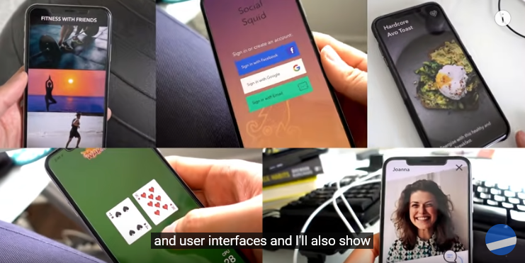

How to Make an App for Beginners (2019) - Lesson 1. (2019). *YouTube*. Available at: <https://www.youtube.com/watch?v=jniJeamcIUU>

Some of the skills to be gained when creating a Mobile App

* Understand the **overall lifecycle** of what goes into making apps
* A run down of the **tools and equipment** to get set up and ready
* Learn how to use **Xcode** – it’s the tool you use to build working apps
* Understand the different **layers** of an app – its interface, its behavior with user interaction
* Get important basics in the **Swift programming language** – syntax, logic, constructs etc.
* Develop A+ **coding skills** in best practices, debugging and design patterns

‌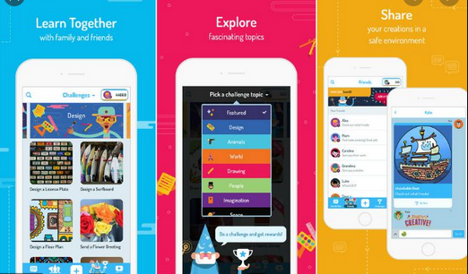

Educational apps are a great way to teach children away from the classroom. The flexibility means they can work on a range tablets or smartphones anywhere and at anytime.

The apps need to be colourful and interesting, so children do not lose interest and concentration. Games are a great way to keep kids entertained and teach them at the same time

Ten Ten Systems Ltd. (2017). *3 Advantages of Educational Apps - Apps for Learning | Ten Ten Systems*. [online] Available at: <https://www.1010systems.co.uk/three-advantages-of-educational-apps/>

‌