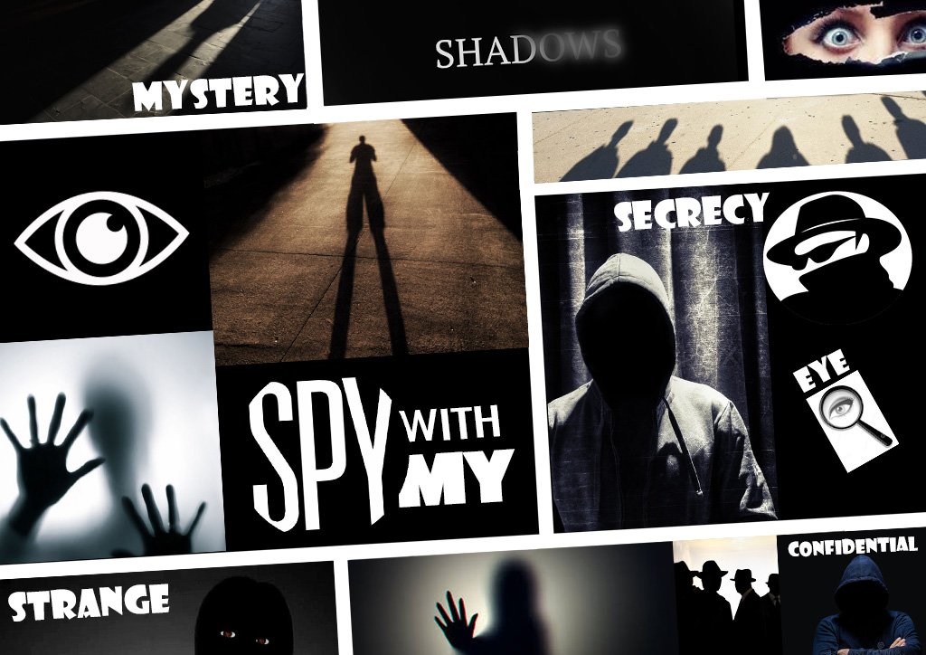

This theme describes something which is kept secret. Not showing a true personality or face and is disguised just like being hidden in a shadow that nobody can see. It’s something of a mystery which could be kept confidential and strange at the same time.

The theme can be interpreted as something which is strictly confidential and not revealed to the public. Secrets are involved and can only be shared to those who have special coded access. This type of incognito is used in politics to hide government top secret information which are highly confidential. Incognito is also used as a secret browsing tool on the internet which hides your browsing activity.

I researched the theme through some film and imagery media online. I personally enjoy watching spy movies such as Mission Impossible, Bourne Identity and James Bond and used this idea in my moodboard.. I have used some of the spy, shadows and mystery images with standout words and used the famous saying ‘I spy with my little eye’ into my moodboard.