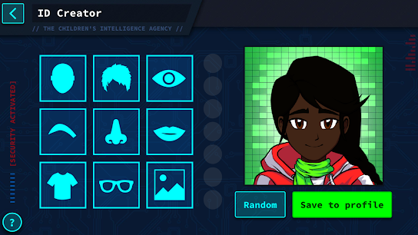 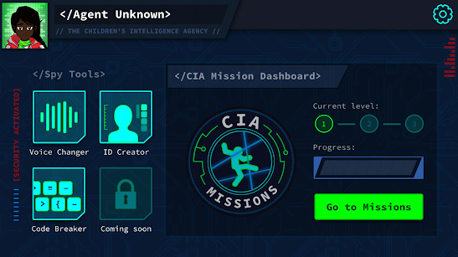 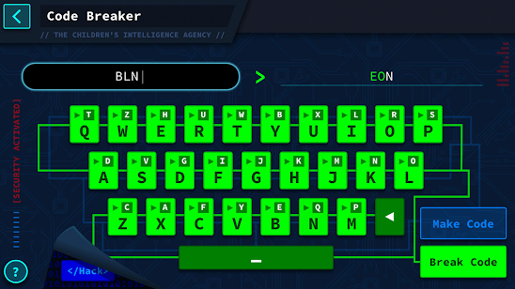

Select different disguises to create your own

Spy character. Choose from moustaches to wigs and dark glasses

Spy character will be given clues to break the codes

Spy Mission details will be given to help with completing the levels and missions

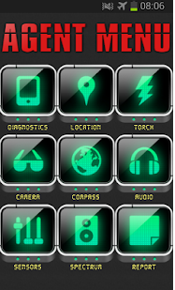 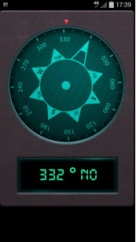 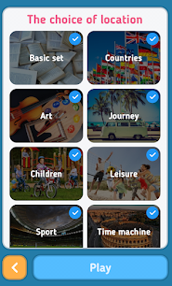 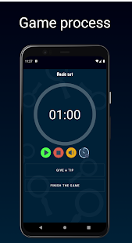 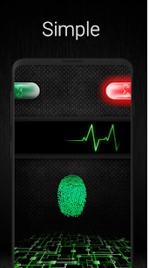

Screen can have a finger print scanner for the kids to access the spy game and extras

Spy Game will have a time limit to complete. Countdown timer will show on screen

Screen to show different locations set up at the festival for searching for secret codes

Mobile app Compass to help find the locations and search for the secret codes

Screen menu to show different options to help with the levels and finding the secret codes