Mythology research

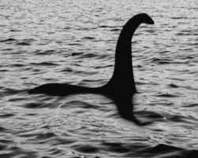

Scottish mythology

Loch ness monster:

the legend of the loch ness monster is that it is a cryptid creature that has been spotted in the biggest lake in Scotland called loch ness. People believe it could be a plesiosaur that is presumed to have gone extinct 65-200 million years ago. There are also photos of the creature relating to the 1930’s. At this point most people just see it as a myth and dismiss any "evidence", however in 2019 there have been 14 reported sightings so far (the most in a single year this century), suggesting that although it may not be a plesiosaur there might actually be something down there. If you'd like to try your luck at spotting the legendary creature from Scottish folklore then you could visit Loch Ness with us on our Loch Ness, Glencoe & The Highlands Tour which departs from Edinburgh and Glasgow and take a cruise to get the best views.

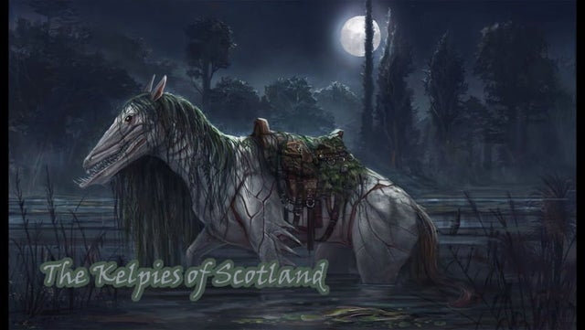

Kelpie:

The kelpie is water houses that lore their victims to the water to drown and almost every body of water in Scotland has a kelpie story, but chief among them is Loch Ness. This might be because the loch is so huge and has many small settlements near it. The tale of kelpie dragging children into rivers and lochs was a warning for kids to stay away from the water edge.

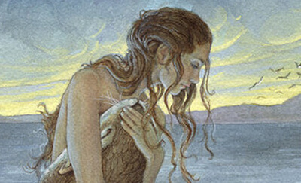

Selkies:

The selkies are creatures that take the form of seals and shed their skins to look human but they only do this once a year on midsummers eve. While most mythological water creatures end up as nasty and mean-spirited like the kelpies and the blue men of minch, selkies are kind and helpful. Unfortunately, many selkies stories are romantic tragedies.

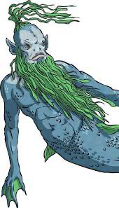

The blue men of the Minch:

The Blue Men of Minch are also known as storm kelpies. They’re blue-skinned men who live in the water of The Minch. They spend their time looking for sailors to drown or boats to sink, using their powers to create storms.

The only way to avoid the wrath of the Blue Men would be to have a quick-witted and sharp-tongued captain. Before they attacked a ship, the chief of the group would shout out a line or two of poetry. The captain would have to complete the rhyme, or else the Blue Men would sink the ship! Because of this, these Scottish mythical creatures have inspired many seas shanties.

American mythology:

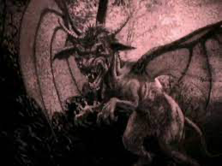

The jersey devil:

The jersey devil is depicted as having a horse head, bat-likes wings and claws- although it’s rarely seen. Instead, it makes its presence known via eerie wailing, awful cries and rampaging sounds Trenton councilman E.P. Weeden reported being wakened in the night by flapping wings outside his bedroom window; in the morning he found cloven prints stamped into the snow.

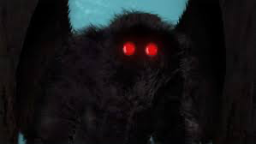

Moth man: Driving home late on the night of Nov. 15, 1966, four young adults noticed two red lights in the shadows of the West Virginia Ordnance Works, a former TNT factory from the World War II era. Stopping to investigate, they claim to have discovered a 6- or 7-foot (1.8 or 2 meters)-tall creature that resembled a man with large wings. The two red lights they'd noticed were its eyes. As they raced home in their car, the beast flew after them. Once the news got out, more than 100 people in the Point Pleasant, West Virginia region reported seeing "Moth man" over the next year.

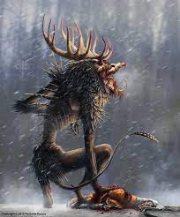

Wendigo: the story of the wendigo comes from native American folklore and is linked with cannibalism. The creature, which tends to be found in Northern Minnesota and Canadian forests, is typically described as a 15 foot tall man-beast with large eyes and claws, an emaciated frame and an insatiable appetite for human flesh.

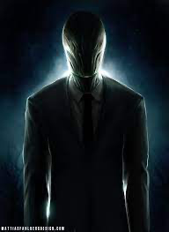

Slenderman:

Slenderman is tall man pale a with no face that wears black suit and tentacles coming from their back. The myth of slender man was created in 2009 by a Floridian called Eric Knudsen in a Photoshop contest since then people have then started saying they saw him and teenage girls almost kill a friend by stabbing them, in the hopes of pleasing Slenderman, who they thought was real. That's the most terrifying Slenderman story of all.