Sonic unleashed analyse:

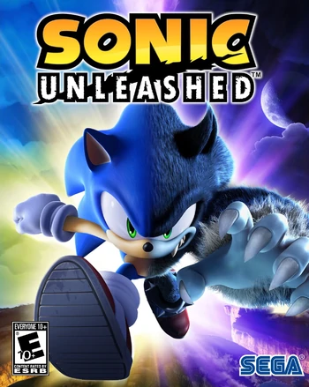

Roles:

audio director- makes the soundtrack

3d modular- did all the character 3d designs and made the world 3d

Script writer- writes the story

Artists- make all the designs like how the colours look and how the characters look

Level designer- designs the level and add the obstacles

Programmer- writes the code for the game to come to life

Publisher- published the game to the public

Developer- checks for bugs in the game and helps with production

Producer- oversee development

Photographer-took the photo for the game levels and where it will take place

Voice actors- voiced the different characters from the game

What is good about it: