Fantasy

Fantasy is a genre of literature that features magical and supernatural elements that do not exist in the real world. -masterclass.com. Some fantasy movies are lord of the rings, harry potter, Percy Jackson and never-ending storylord of the rings

 harry potter

Percy Jackson

 never-ending story

Dark fantasy

Dark fantasy is a subgenre of fantasy literary, artistic and cinematic words that incorporate disturbing and frightening themes of theme of fantasy with elements of horror has gloomy dark tone or a sense of horror and dread – Wikipedia

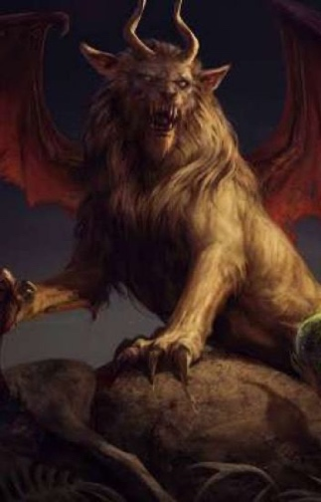The fantasy creature is the manticore, hydra, minotaur, chimera, kitsune, dragon, griffin, hippogriff.

manticore:

The Manticore originated in [Greece](https://harrypotter.fandom.com/wiki/Greece), and is as rare as the [Chimaera](https://harrypotter.fandom.com/wiki/Chimaera). The sting of the Manticore causes instant [death](https://harrypotter.fandom.com/wiki/Death), and it is reputed to croon softly to its victims as it devours them. A manticore has the head of a human, the body of a lion, and the tail of a scorpion that will kill anyone instantly. A manticore’s skin repelled all known charms. - <https://harrypotter.fandom.com/wiki/Manticore>

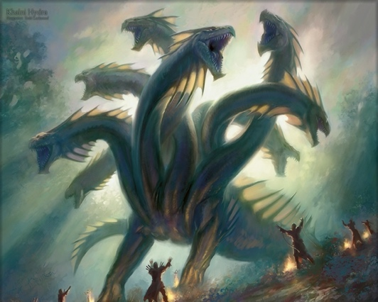

The lernaean hydra:

the lernaean hydra or hydra of Lerna is a serpentine water monster in Greek and roman mythology. Its lair was the lake of Lerna in the argulid, which was also the site of the myth of the danaides. Lerna was reputed it be an entrance to the underworld and archelogy has established it as a sacred site older than Mycenaeans Argos. - <https://en.wikipedia.org/wiki/Lernaean_Hydra>

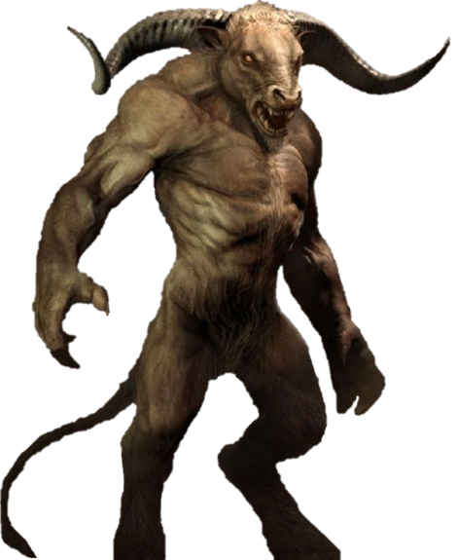

Minotaur:

Minotaur, Greek Minotautos Greek mythology, a fabulous monster of Crete that had the body of a man and the head of a bull sent to Minos by the god Poseidon for sacrifice. Minos, instead of sacrificing it, kept it alive; Poseidon as a punishment made Pasiphae fall in love with it. Her child by the bull was shut up in the labyrinth created for Minos by Daedalus. - <https://www.britannica.com/topic/Minotaur>



Chimera:

The chimera according to Greek mythology, was a monstrous fire-breathing hybrid creature composed of different animal part from Lycia, Asia Minor. It usually depicted as a lion, with the head of a goat protruding from its back, and a tail that might end with a snake’s head. - <https://en.wikipedia.org/wiki/Chimera_(mythology)>

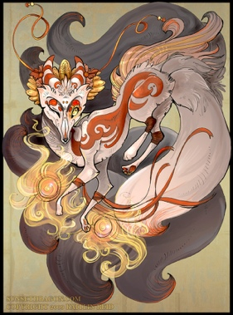kitsune:

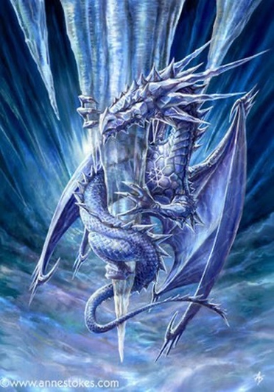in Japanese folklore, kitsune are intelligent foxes that possess paranormal abilities that increase as they get older and wiser. According to [yōkai](https://en.wikipedia.org/wiki/Y%C5%8Dkai) folklore, all foxes have the ability to shapeshift into human form. While some folktales speak of Kitsune employing this ability to trick others- as foxes in folklore often do – other stories portray them as faithful guardians, friends and lovers. - <https://en.wikipedia.org/wiki/Kitsune>

Dragon:

a dragon is a large serpentine, legendary creature that appears in the folklore of many cultures worldwide. Beliefs about dragons very considerably through regions, but dragons in the western cultures since the high Middle Ages have often been depicted as winged horned, four legged and capable of breathing fire. - <https://en.wikipedia.org/wiki/Dragon>



griffin:

the griffin is a legendary creature with the body, tail and back legs of a lion ; the head and wings of an eagle; and sometime an eagle’s talons as its front feet. Because the lion was traditionally considered the king of the beasts, and the eagle the king of the birds, by the Middle Ages, the griffin was thought to be an especially powerful and majestic creature. - <https://en.wikipedia.org/wiki/Griffin>

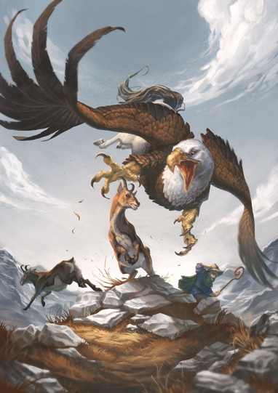

hippogriff:

Hippogriff, a legendary animal that has the foreparts of a winged griffin and the body and hindquarters of a horse. The creatures were invented by Ludovico Ariosto in his Orlando furioso and was based on a proverbial phrase about crossing a griffin with a horse that was used to signify an impossibility or incongruity. - <https://www.britannica.com/topic/hippogriff>