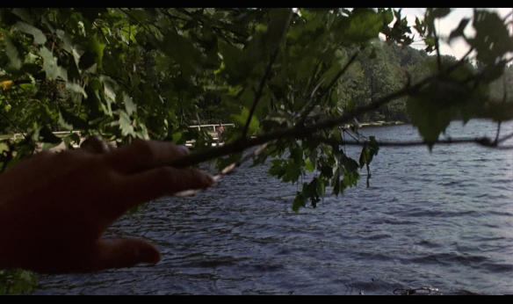

This is pov shot showing the killer spying on a victim from the woods

<https://www.youtube.com/watch?v=0pIfyTXphgE>

this is the tracking shot of the little boy from the shining riding his bike through the hotel

<https://www.youtube.com/watch?v=Q1JW_YtSX44>

this is a tilt shot of star wars showing a black screen then showing a planet and space ships