Artist research for Robot Concepts

Alan Blackwell

Alan Blackwell is a south Australian freelance concept Illustrator, who uploads sketches and sculpts of imaginative Robots. Blackwell has worked with many big companies such as Hasbro, Black lab games and DeNA Canada. He draws robots like mechs and other concepts. Blackwell’s work is mainly done digitally and traditionally. He found his love for Illustration through Star Wars and Transformers. Blackwell creates sci fi machines brought to life through his art. Blackwell pays attention to detail and puts a lot of line work and detail into his work. I like his Illustrations because of the line work in his drawings and the detail in the drawings. I like the colour grading and the robot designs because they are highly detailed and unique. Ideas I can take from his are the designs and shapes of the robots and the simplistic colour scheme.

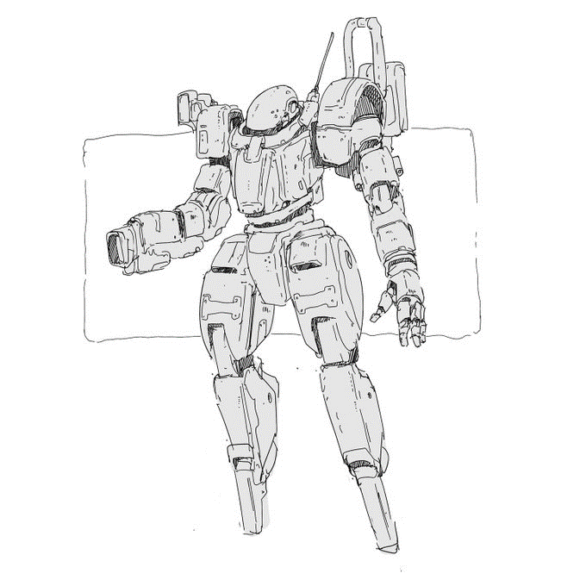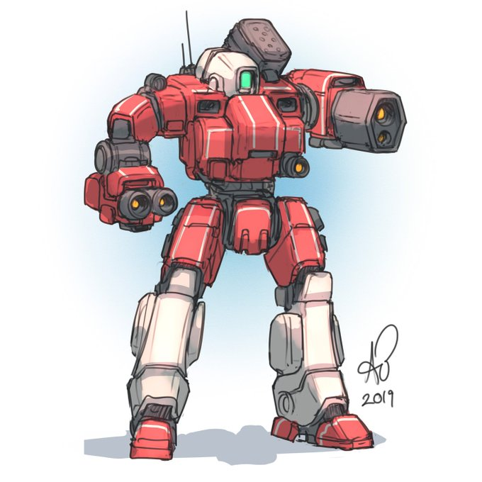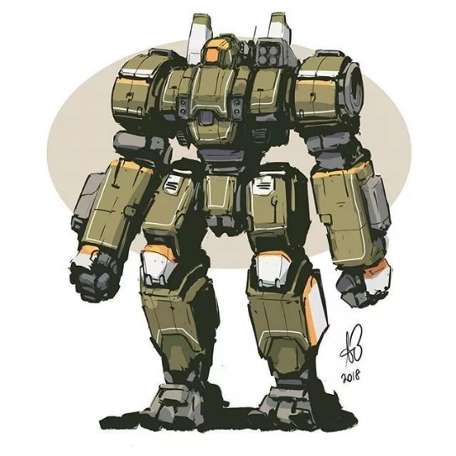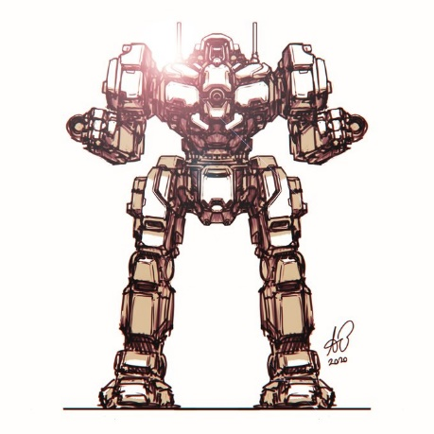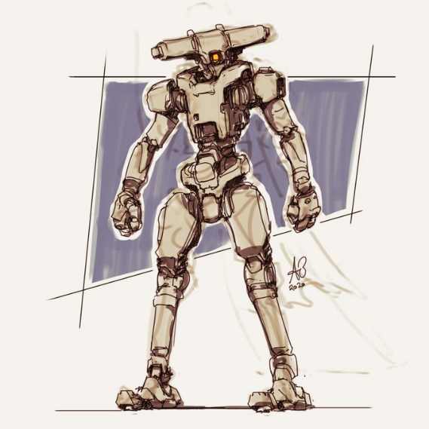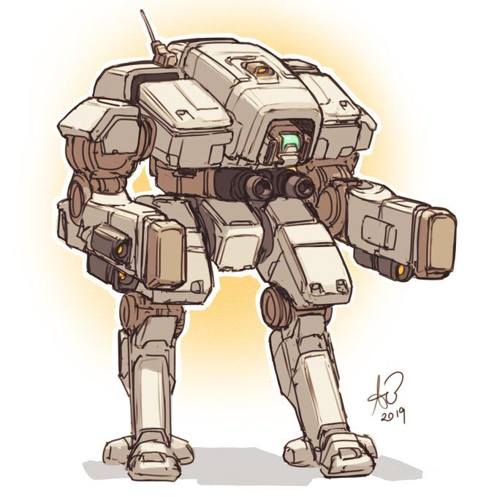

Matt Dixon

Matt Dixon is a freelance Illustrator who has been a concept artist for ten years. Dixon has worked in video games and the entertainment industry. Matt Dixon has been doing digital art since 1980 by assembling ASCII characters into images on Commodore VIC-20 and has been working digitally ever since. He has worked with companies like Electronic Arts, Blizzard and DeNA. His art is made digitally through photoshop and Illustrator. I like his work because of the simple designs of the robot and the simplistic design and simple colour choice. I like the use of textures and lighting in his images it makes the robot more realistic.

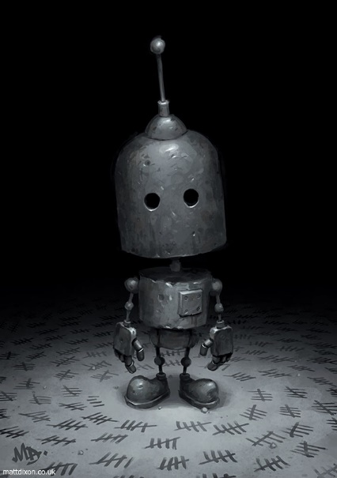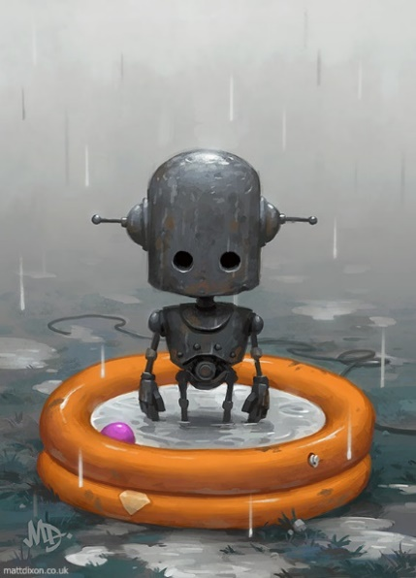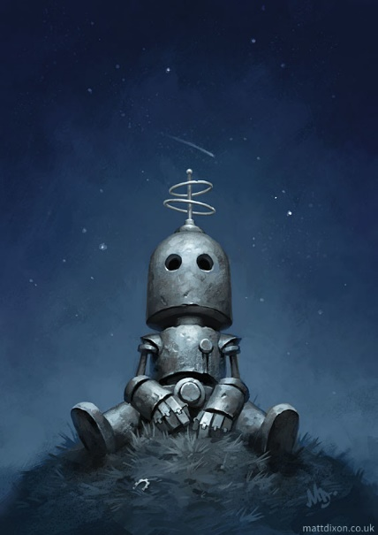

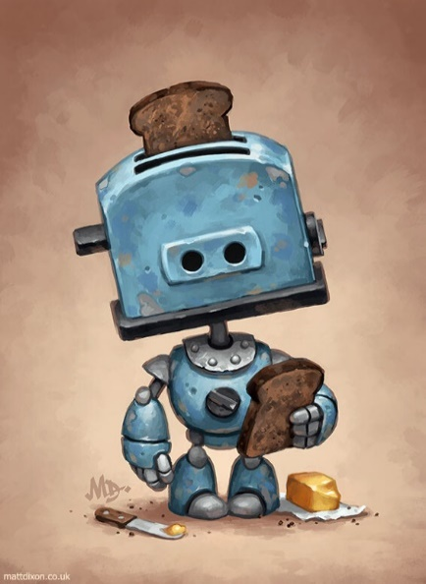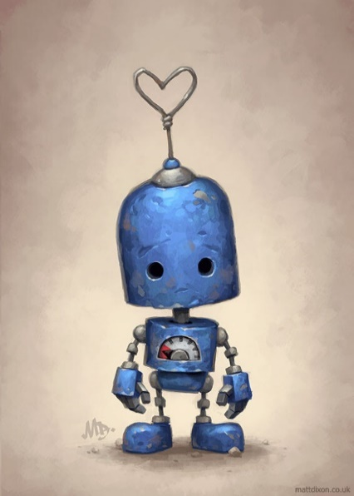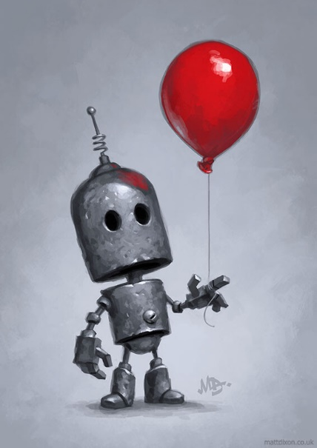

Janice Chu

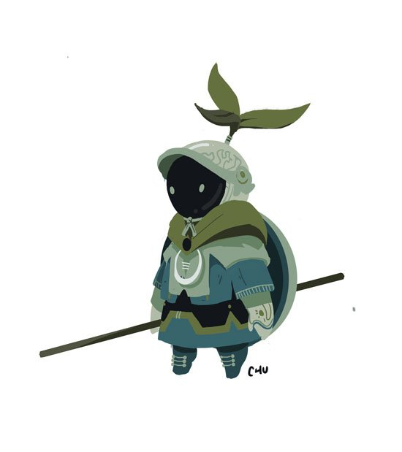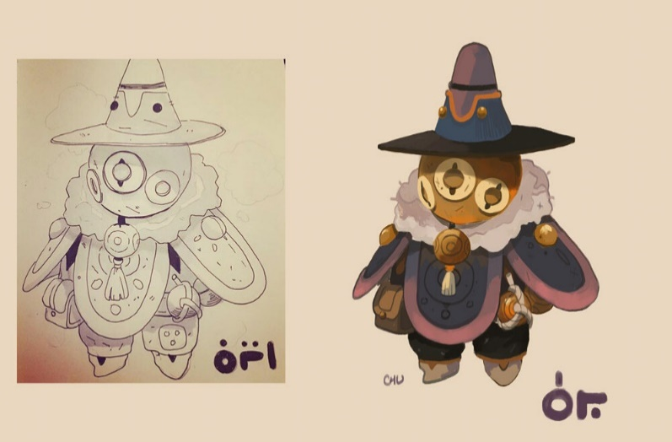Janice Chu is a concept artist who has done work for games such as overwatch and done UI design for the game. Janice Chu also has done work for the game company naughty dog and developed the characters in the Uncharted Games. Her work is usually done digitally through photoshop, adobe Illustrator, Sketchup and Cinema 4D. I like her work because her robot designs have a lot of detail and are designed in a way that you can tell what type of mood is created through the design of the robot. Her work has an interesting colour scheme that brings out the robot and the mood and tone wanted to be made through the colour scheme. The work is done using vectors so simple shapes are used to create the design.

