*Bailey Haggan FMP* Reflective Journal

# What have you created today?

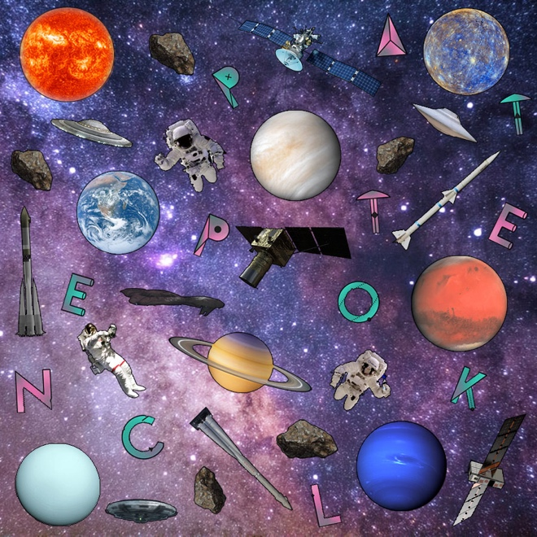

Over the past week I have developed and made a collage of everything related to space such as planets , meteors , rockets , satillites and astronauts and a space background aswell.

Creating this has been quite fun to do and was much more enjoyable than the animations and the posters I have made for my fmp and loved making this collage of everything space.

# What obstacles or difficulties did you face?

I faced many challenges whilst making this firstly adding everything was difficult as I couldn’t find many transparent images to do this originally and almost had to leave it , another thing was trying to fill any big gaps and another thing was when photoshop freezes I lose the work I have already developed and made.

# How did you overcome the above challenges?

I overcame the above challenges by managing to find the transparent photos of everything I needed for this collage and I managed to fill the big gaps in my collage by adding more stuff on to reduce them but there still some gaps however im gonna leave it the way it is for now as im happy with it , and I managed to get my work back up by restarting the system and luckily recovered the work I made and saved it every 10 minutes to not lose it again.

# What would you do differently next time?

What I would do differently if I did this again would be to sketch out how I would make the collage and use the sketch to have ideas so I can use it to make my collage and make it look better and should of pre planned it all before starting the collage.