*Bailey Haggan FMP* Reflective Journal

So I created my own poster for the pocket planet festival one that’s poster size and one on the sides I really enjoyed making these two I loved how I developed and made them , I love how I designed them.

These were lots of fun to my favourite has to the original simple and basic and people will know where it is and stuff

Overall – I really enjoyed this part of the FMP

# What have you created today?

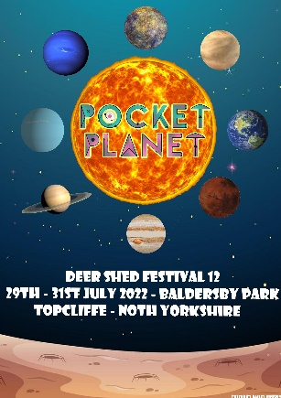 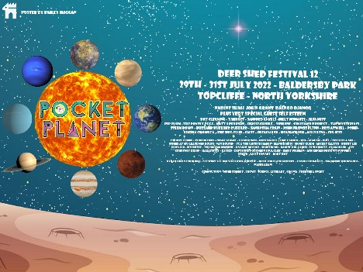

# What obstacles or difficulties did you face?

I didn’t face many difficulties with this one but if I have to say it will have to be writing as it took too long to write up and I couldn’t copy it as it would send me to another part of the website I was copying it off from and would make loads of spelling errors along the way whilst doing it.

# How did you overcome the above challenges?

I overcame the above challenges by going back and editing the errors I have made and giving it a better font size than the one I already had used making the posters look neat and stand out very well in my opinion.

# What would you do differently next time?

I would go back and change the poster to make it more realistic however I am very happy with the poster and changing it up wouldn’t make much of a difference in my opinion and that’s what I would do differently if I were to do the project again.