Game Design Written Plan Template

This document will help you write up and develop your game design plan. Use it how you see fit. Be sure to add your research into this document there is a bibliography at the bottom to input your hyperlinks to your research.

# GENRE/TYPE/ DESIGN

Genre – Sport & Puzzle Game

Type – Puzzle & Strategy

Design – 2D or 3D

# RESEARCH

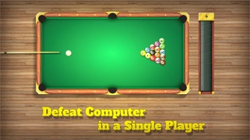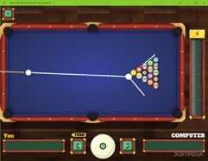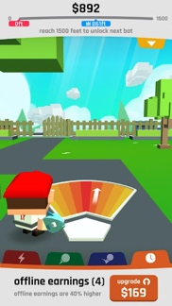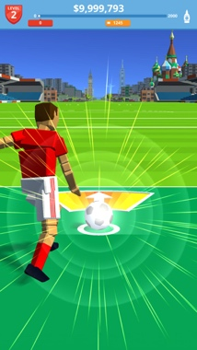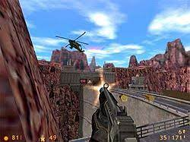

STORY/PLOT

The plot of this game focuses on a game of snooker but it is not an ordinary game it’s a game where you hit the ball , and the longer the ball goes on for the more points you get but you have to avoid obstacles if you hit an obstacle the ball will stop and you get coins for how you went , which can be spent on other balls , more cues and boost’s.

# CHARACTER LIST

This game will be first person if its in 3d or aerial view if in 2d there will not be any characters in this game as you will just hit the ball with the cue , there will not be any NPC in this game.

# MISSIONS/TASKS/PROGRESSIONS

In order to progress in this game you will have to hit very far if you score a certain amount of points the more you will level up for example you need 100m to level up to level 2 in order to progress and there are no missions in this just the task of levelling up whilst avoiding obstacles at the same time.

# AWARDS/ACHEIVEMENTS/WINNING/END RESULT

The awards you get in this game are coins , the further you hit the ball and land far the more coins you can get and you can use the coins to buy some more stuff extra balls , extra cues and boost and they will all have a special ability to make your game experience better.

# EXTRA ELEMENTS

Bonus Games , there will be a bonus game and it can only be unlocked if you score than 100,000 points and the bonus game is where you can get lots of coins there wont be obstacles just coins and hit the ball and when the ball stop the amount of coins you will get

LEVEL DESIGN

# STEP 1 – BACKGROUNDS

The background of this game will be set in a snooker arena and you will play on the normal snooker table and there will also be obstacles in the background as well.

# STEP 2 – START POINT

The start point will start at one end of the table and there will be the ball , the cue and the meter which will be used when pressed to improve the speed of the ball to make it faster and further.

# STEP 3 – END POINT

This game will be endless meaning their will not be the other end of the table but the end point will end either when the ball hits an obstacle or the ball slows down and stops putting an end to the game before you can start playing it again.

# STEP 4 – OBSTACLES

The obstacles in the snooker game can be castles , brick walls , plant pots , bottles and other obstacles will be in my game and their responsibility is stop the ball from going further although some obstacles have tunnels ,so the ball can continue on until it hits an obstacle or slows down and stops.

# STEP 5 – NPC’S

In this game there are no NPC’S or even a main character just a ball and a cue with obstacles , this game will lack characters but this game I’m planning will be fun and addictive for everyone to enjoy yet I’m just making a demo I’m not making a full game.

# STEP 6 – PLOT & WHY?

This game does not have much of a plot the main aim to hit the ball as far as you can to score points in order to get coins whilst avoiding obstacles at the same time .

# STEP 7 – MOVEMENT & CONTROL

The controls of this game involves moving the cue in a position that feels comfortable for the player and then try to hit the red for a fast experience and the movement can range from smooth , fast , very fast and very fast can make the ball move further when hit when to get more coins.

# STEP 8 – CONCLUSION

This game will only conclude for example when the ball hits an obstacle or if the ball slows down and stops and the game will conclude before restarting before you can play again and try for a better score.

BIBLIOGRAPHY

Include links to all your research here, all the websites you’ve looked at, the YouTube clips you’ve watched, even books and bogs you’ve explored, copy and paste the hyperlink below…

Theres not really much but copy and pasted images from google for the research part