Candidate Name
Joseph Colvill

Candidate Number
10619316

Project Title
Protect your devices for virus

Rationale (Approx. 100 words)
This Project is theme about to use incognito for Deershed Festival that is three-day festival. Also, I have to produce a creative media product. Furthermore, I have chosen to do design project because I love design and find design fun. I also, have the skills and knowledge surrounding digital design to support this project. Plus, I mostly interested in design. In this/past year I have done- robot design. I used photoshop, sourced images of internet and used newspaper for both technical and print design. Digital design and physical. I also, have experience designing for games, producing logos, banners for different clients.
Project Concept (Approx. 200 words)
This project concept is about how protect you or your child for computer virus. I think my audience is young adult to oldy person either with or without kid. The title might be “How to prevent your devices to caught a virus”. Plus, I will have graphics on the website. Interactive so people can explore the site and find out more about protecting your computer. Also, the graphic to represent the virus and clear branding for all media materials.

Evaluation (Approx. 50 words)
Research- Start on 22.02.2021 to 23.03.2021. Is to research about the computer virus and protection (subject)plus it has used the theme is incognito.
Research- Start on 22.03.2021- 04.04.2021- design methods and approaches (discipline).
Planning and Designing- Starting on 24.03.2021 to Deadline on 07.04.2021. To build rough idea plan like design. After that I will starting to design the Leaflet and a website.
Present to other people and change something around- 08.04.2021 to 10.05.2021. This to present it to people in festival or/and classmate and to gather feedback and see what good about it and what bad about it with survey. And then change something around at the end of this.

Proposed Research Sources & Bibliography (Harvard Referencing)
Secondary research: Quick Navigation ; 1Use Antivirus Software: 2 Don’t Open Emails from Unfamiliar Users: 3Don’t Visit Suspect Websites: 4Strengthen Your Internet Browser Security Settings: 5 Turn on SmartScreen Filter for Microsoft Edge: 6 Pay Attention to Windows SmartScreen Notification on Your PC: 7 Keep Your Windows Up-to-Date: 8 Use a Firewall App: 9 Turn on User Account Control (UAC): 10 Clear Caches and View History for Your Web Browser: 11Don’t Install Cracked Software: 12 Pay Attention to Your Downloaded Files.

The reference is How to Protect Your Computer from Viruses? (12 Methods) (minitool.com). It is available/online December 04, 2020.

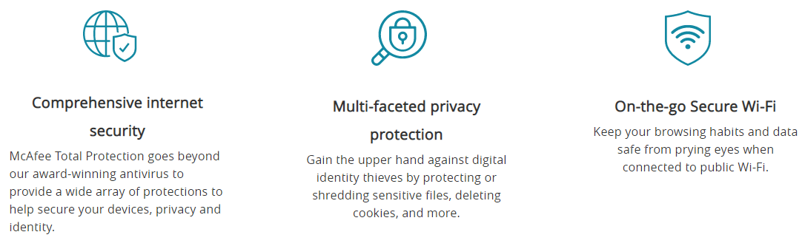

The references is McAfee Total Protection 2020 | Antivirus software. Up to date (24/05/2018).

- Don't open email messages from unfamiliar senders, or email attachments that you don't recognize - Many viruses are attached to email messages and will spread as soon as you open the attachment. It's best not to open any attachment unless it's something you're expecting. For more information see: Protect yourself from phishing.
- Use a pop-up blocker with your Internet browser - Pop-up windows are small browser windows that appear on top of the website you're viewing. Although most are created by advertisers, they can also contain malicious or unsafe code. A pop-up blocker can prevent some or all of these windows from appearing. The pop-up blocker in Microsoft Edge is turned on by default.
- If you're using Microsoft Edge, make sure SmartScreen is turned on - SmartScreen in Microsoft Edge helps protect you from phishing and malware attacks by warning you if a website or download location has been reported as unsafe. For more info, see What is SmartScreen and how can it help protect me?
- Pay attention to Windows SmartScreen notifications - Be cautious about running unrecognized apps downloaded from the Internet. Unrecognized apps are more likely to be unsafe. When you download and run an app from the Internet, SmartScreen uses info about the app's reputation to warn you if the app isn't well-known and might be malicious.
The reference is Protect my PC from viruses (microsoft.com). And it is available 01/03/2021.

