Documentary research

Below you will find the trailers which I used partly in my documentary. I didn’t use any of the audio as it would most likely have been copyrighted even if it fell under fair use and would have mostly likely just gotten in the way of more voice over.

[CoD: WaW - Launch Trailer](https://youtu.be/ondfCsioE0E)

[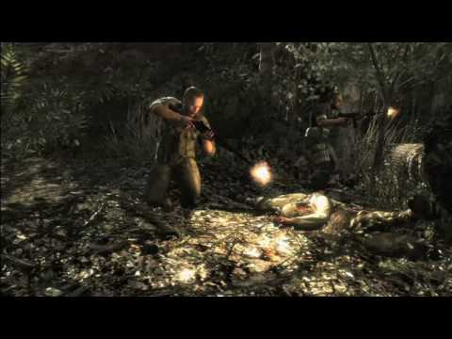](https://youtu.be/ondfCsioE0E)

[Call of Duty: World at War Zombies Bonus Mode Trailer (Official HD)](https://youtu.be/neao27bSRW0)

[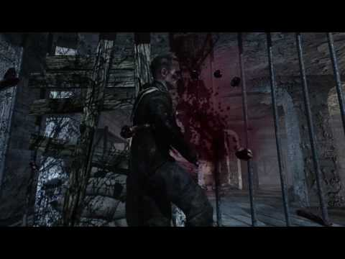](https://youtu.be/neao27bSRW0)

[Call of Duty: World at War Verruckt Trailer #1 (Official HD)](https://youtu.be/cvArR7CFXLs)

[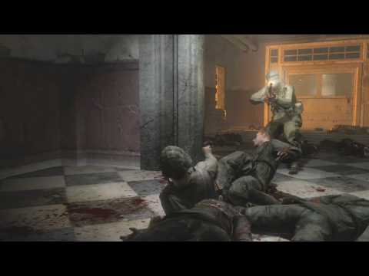](https://youtu.be/cvArR7CFXLs)

[Call of Duty: World at War - "The One" (Official HD)](https://youtu.be/Udac9hVyb48)

[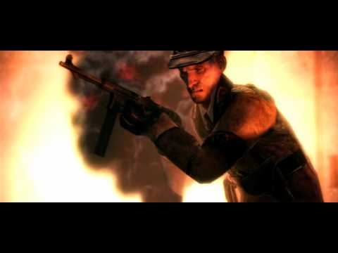](https://youtu.be/Udac9hVyb48)

[Call of Duty: World at War - "Beauty of Annihilation" Der Riese Trailer (Official HD)](https://youtu.be/SAIZ6dNNI3U)

[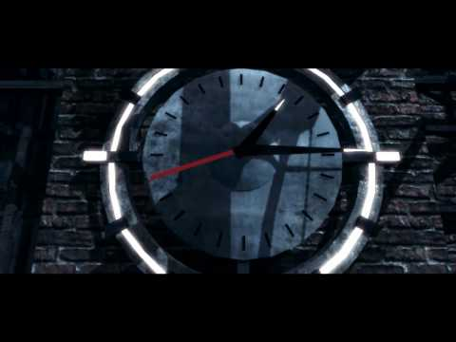](https://youtu.be/SAIZ6dNNI3U)

<https://callofduty.fandom.com/wiki/Call_of_Duty:_World_at_War#Nazi_Zombies>

This is the main site that I used to collect information such as the different details of all the different maps and when they were released. Overall, this site is everything packed into one and I didn’t need any more information from anywhere else as I was also quite knowledgeable already on the game but it was mainly used to back up what I was talking about so I wouldn’t have any misleading information in my documentary.