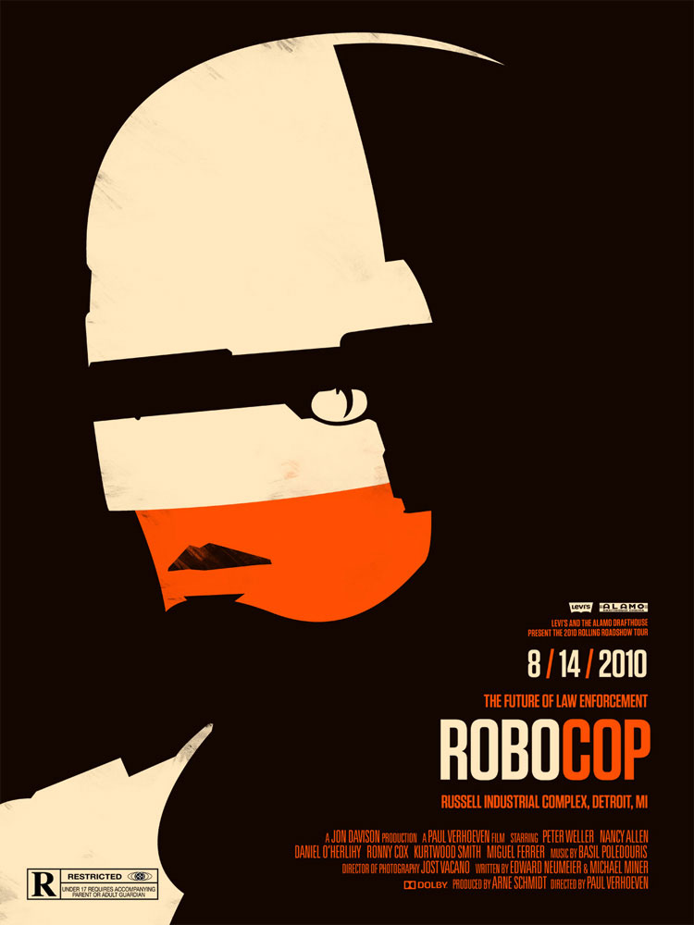

Robo cop poster

The use of colour on the poster shows the humanity left in the cop as only his skin is left in colour but everything else is black and white the text on the poster is very professional and not slanted or disjoined to show professions just like how a police office would be very professional themselves can also see that gun is placed where his visor would be showing that his goal is to serve and protect.

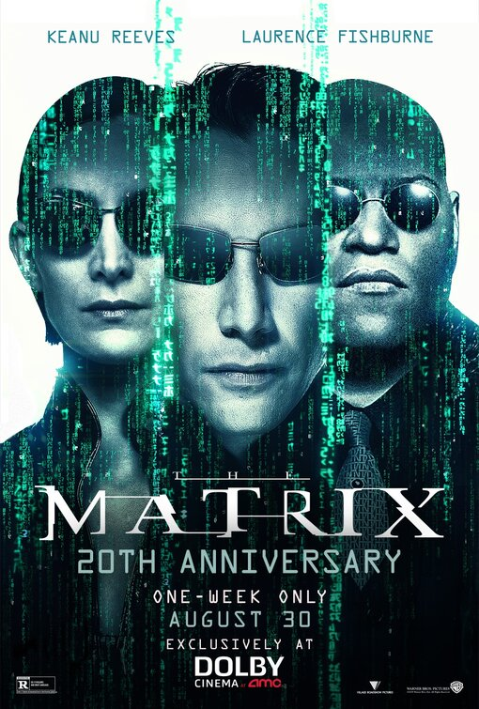

The lack of colour in this poster shows how the world is not as real as it seems as all the faces are seemgly merged together in code as they are also all in the same tone. The wording of the matrix is also distorted and conjoined to show that the world isn't real and that they are living in a fake reality

The lack of colour used in this poster show the kind of evil this film has as there is a lack of colour and emotion which kind of represents how Michael Myers is in the film, he is a cold-blooded killer with no emotion also with the position of Michael on the poster with him being in the top left it shows that he is kind of looming over everybody else and creates a sort of darkness aura around him.