Level design research

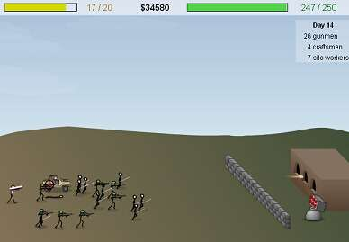

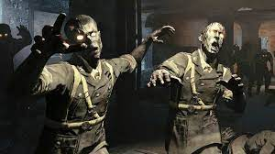

So for our game level we want something nice and simple I want to do this since it is quite simple and easy to do also, I would like to make it 3d in unreal engine with simple mutant enemy’s that approach the player

I also want the game to be a zombie like game similar too call of duty zombies I want it too be like this because there are simple too make but are also very fun and enjoyable to play in my opinion the game is going to take place in a small building

Theme

The theme of our game is supposed to be post-apocalyptic as most of the world is destroyed and only the dead roam the streets the environment is either going to be all destroyed or barely standing

Level design

The level that the game is going to take place in is going to be a fortified house that the main character is living in, and zombies will slowly approach and break inside and kill the player once there get too close