Fmp research (survey)

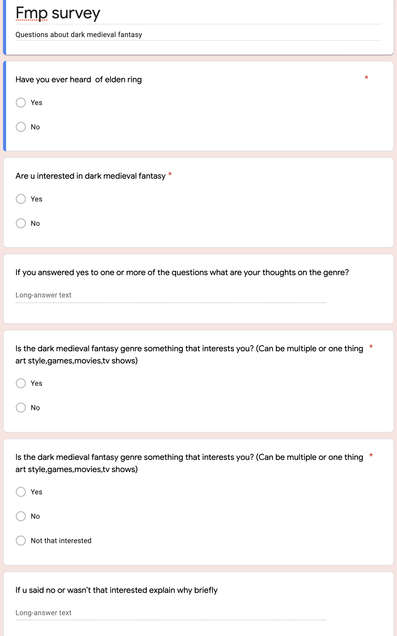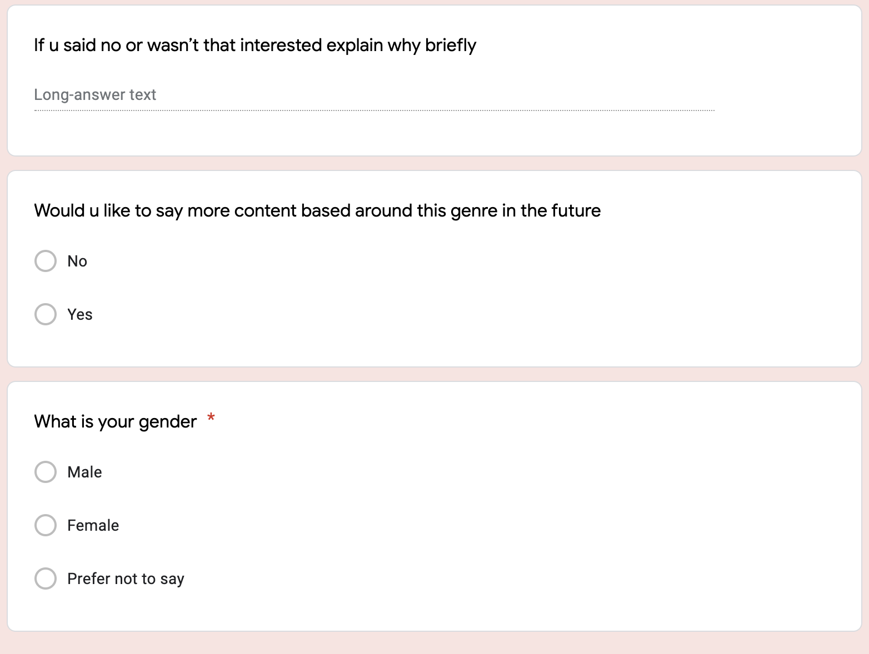

These are the questions that I asked in my fmp survey. This question was made to find out if people were interested in the dark medieval fantasy genre and who was not and to also see how popular this genre is and how much interest for a vast number of different people as I asked a lot of different people to answer my survey to make sure that I got a vast number of different answers as my answers are not just yes and no questions so that enabled me to get better answers and a better insight to the reasoning behind the answers.

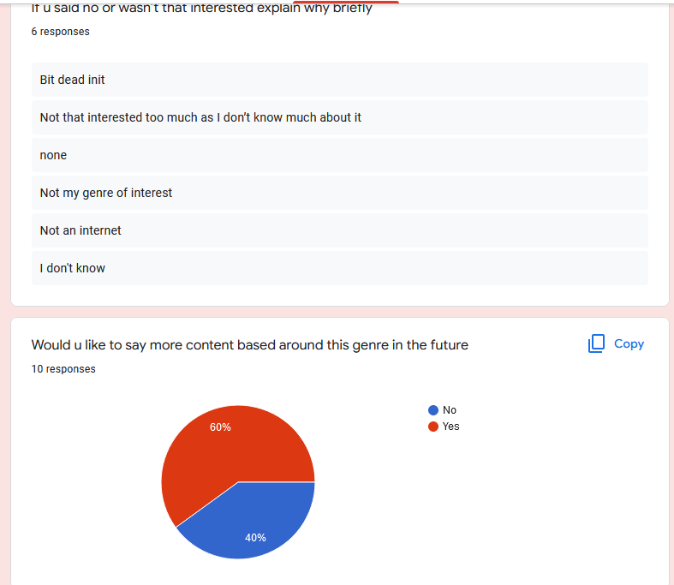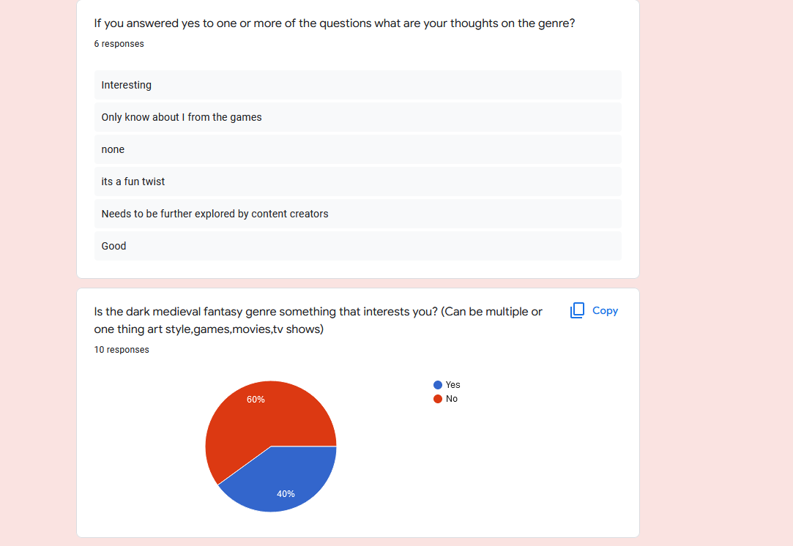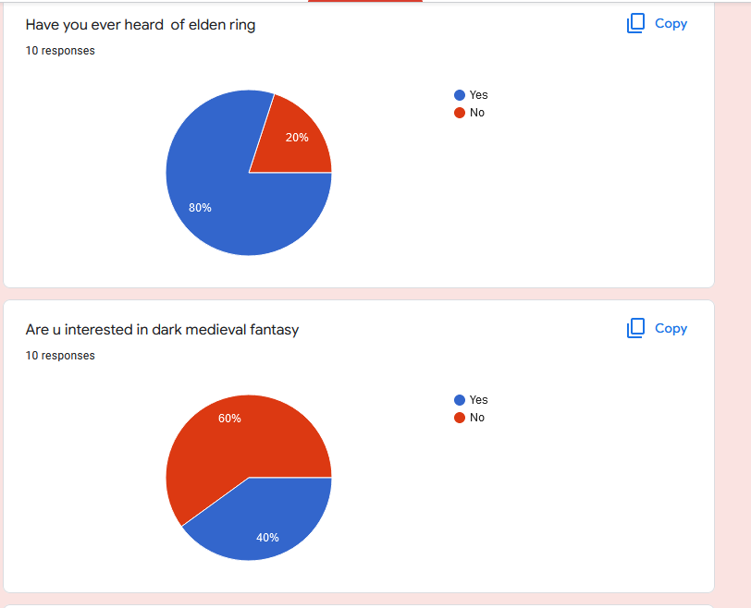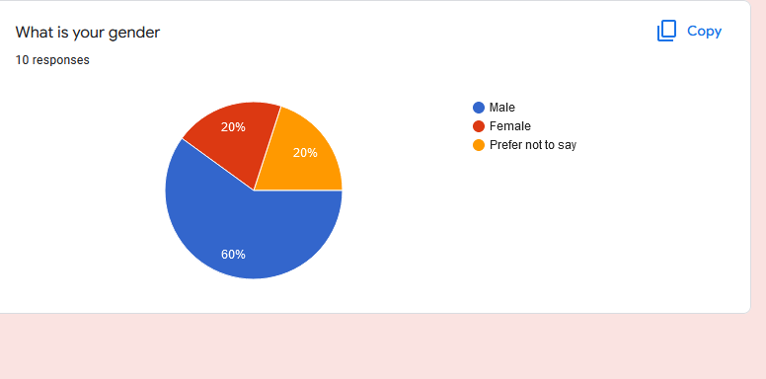

So here you can see all the data that I collected on my questions in my survey and as we can see by most of the answers a lot of people have heard about Elden ring and dark medieval fantasy but as you can see later in the questions most people said that there were not that interested in the dark medieval fantasy genre which could easily main even though Elden ring is extremely popular this peoples first time looking at anything of this genre which can show that Elden ring has actually been a massive opening into the genre for a lot of people as although a lot of people said there weren't interested right now in genre there are open to see more work on it in the future which shows just how much of a impact it has made.