***Game plan***

Buildings: House (Both for/not for entry), Store (entry).

Landmark: Park (children’s playground slide, seesaw, swing, trees and benches)

House (entry): Doors (Both for/not for entry), Windows (Open/closed), Broken windows (entry). (Some Lockpick)

Kitchen: cupboard and fridge.

Front room: 3 coaches and bookshelf.

Backroom: 3 coaches and tv.

Bedroom: wardrobe and bed.

Bathroom: sink and toilet.

Store (entry): Door (Both for/not for entry), Broken windows (entry). (Lockpick). Shelfs and cash machine.

Storage: shelfs.

Pickups: Food & drinks, Weapons, Crafting material, Misc.

Map:

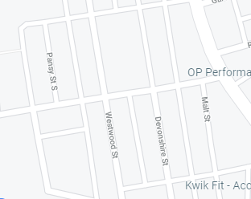

**Detail**

The houses will all be joint with small flat tiled gardens with a 4-step stairway at the entrance. They will mainly be locked and unable to open. It will require you to press “f” to enter and load a separate level. You will start off in a hallway leading to stair start ahead with 2 rooms on the left beside each other. The first room at the front will have 3 couches and a bookshelf (Books may be collectable). The backroom will have 3 couches and a tv and at the end of it will be a room leading to a kitchen. The kitchen will be small with open cupboard that may potentially have food canned, chocolates and drinks. It will also include a fridge that may have fresh food and drinks, which have a better overall effect on the player. Upstairs will include 3 bedrooms and a bathroom. The bedrooms will have wardrobe and bed with collectable clothing. The bathroom will have a sink and toilet that may have such as painkillers and bandages on them.

The stores will have a glass window and a door. You press “f” to enter starting a loading screen. It will include 4 shelfs 2 in the middle and 2 on each wall with a counter at the end.

Behind the counter will be a door to a storage room.

The shelfs will contain canned food, drinks and crafting materials. The storage room will contain usable items on shelfs.