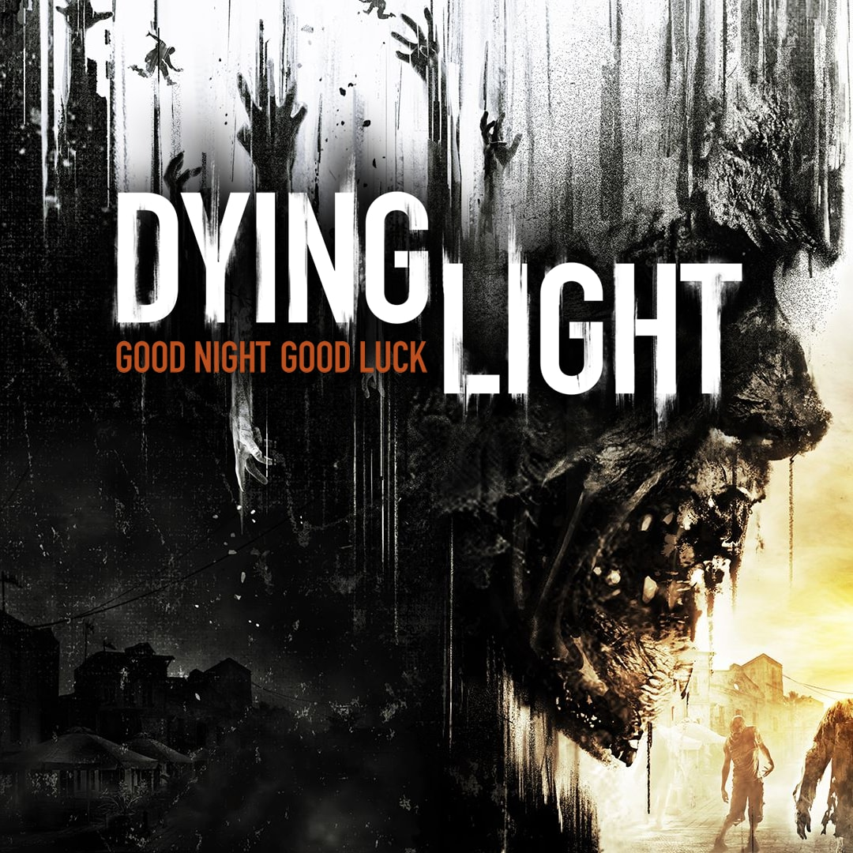

Dying Light

Genre: Action, Adventure, Sci-fi

Violence and Gore: Extreme

Bad language: Strong

Location Turkey, Hanan.

Made by a Polish Company named “Techland S.A.”

Age base: Teenage (14-20)

Gender: Male

Preferences: Gore & Violence, Story based, Zombies, Open world, Parkour

Sold: Europe, Australia, New Zealand

Banned: Germany

Dying light is filled with gore and violence, but no sex. It is not necessarily a scary game. It is played mainly by a young adult/teenage audience and due to its violent tendency, I would assume it is not for the faint of heart. Another key point of the game is the fact that all the other main characters other than one is a girl, which inevitably dies. This for me is a key point and shortens the range of their target audience as it seems more male prioritised.

The game is quite relatable to the gameplay of resident evil 5 with features of assassin creeds parkour style with an open world map. This along with other features/events such as the online battles and attacks that it is not just story based. It is a game wanting their audience base to not only be attracted to the story, but other features too. This would make the game play time longer while creating a community that love it for its gameplay and events. It alternates from the story based to online CO-OP or Zombies vs Humans modes.

Recently due to its sequel Dying light 2 coming out and sales on prices the games sales have increased.