**Media codes and convention**

According to TE KETE IPURANGI (2019) Codes and convention are codes of a system of signs which creates meaning. Codes can be divided into two categories technical and symbolic. Technical codes are all the ways where the equipment is used to tell a story in media text. Symbolic codes are to show what is beneath.

Symbolic codes: symbolic codes are social nature. Symbolic codes in media include

* Setting
* Mise-en-scene
* colours

Setting: setting is the time and place of a narrative when discussing this you can describe what the story is going to be like or just using a specific scene.

Colour: colour is important when it comes to all forma of media because all colours have connotation depending on their context and genres. For example, red symbolises love and anger and others like strength power and courage and evil.

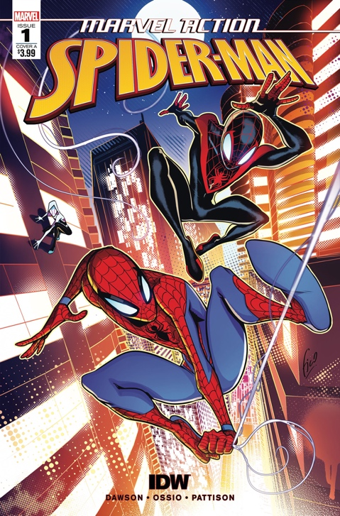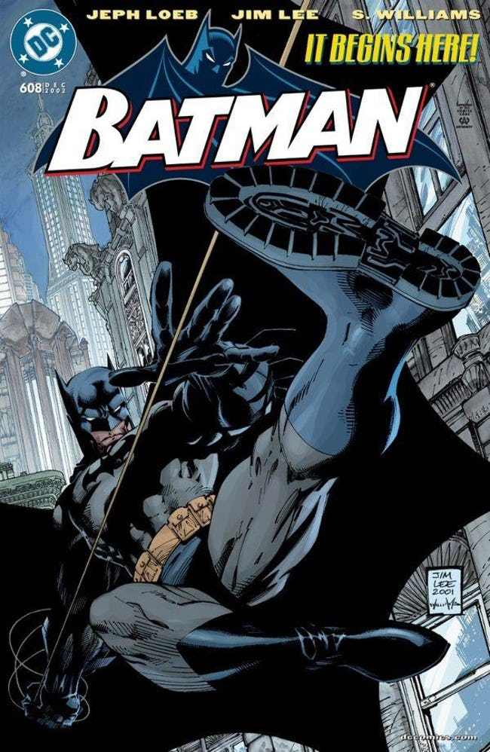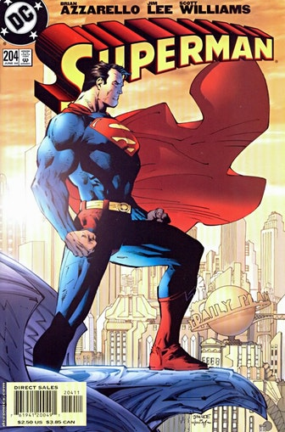

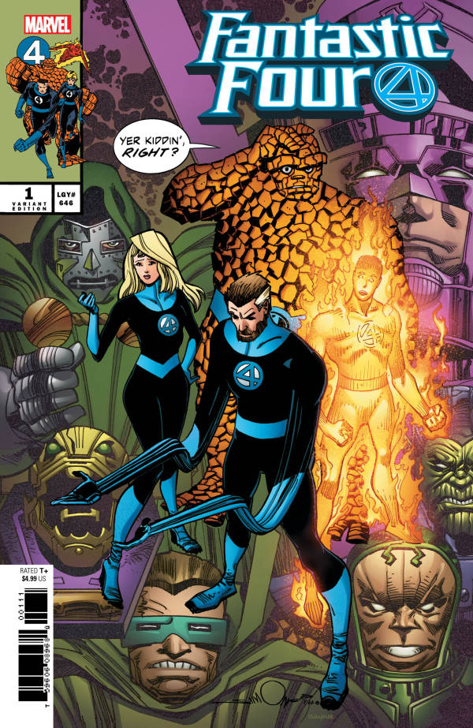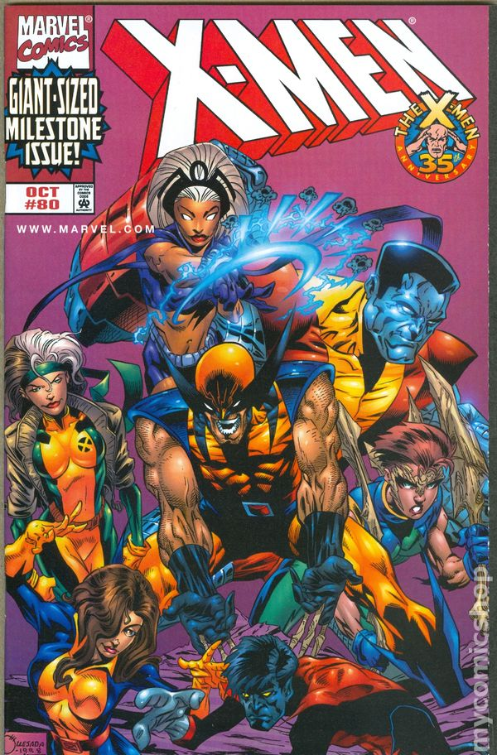

Spiderman cover: the setting for this comic cover is set in a cityscape. This is effective because it portrays the character of Spiderman. Also, the architectures are bright which creates a lighter tone. The colours that are used are blue, red, black and yellow are very vibrant and they stick out to the target audience also the colours that are used makes the brand recognisable to the public. What’s in this cover is cityscape background and the lighting convey a warm and bright tone. The characters that are in the cover are three characters the main one being Spiderman front in centre along with miles and spider Gwen in the background. the costumes that are shown are very dominant because it makes the character recognisable.

Batman cover: The setting for the batman cover is set in a cityscape and is set at night. This is effective because it fits in with the nature of batman and the characterisation of him and gives the target audience a bit of context of what he’s about. The colours and or shades that are used are grey, black and the lighting that is used is dim. This works for the cover for batman because it portrays him as a dark gritty character and it makes the brand recognisable to the target audience and the public in general. What’s in the cover is the cityscape and the dark setting which fits with the character. The character that is included in the cover is batman which is recognisable to the public and the colours that are used on the costume are very dominant. This is effective because it makes the brand recognisable and it gives the target audience a better idea of the type of character he is.

Superman cover: The setting for the superman cover is a cityscape and it is set in broad daylight. This is effective because it fits with the character of superman as being bright. The architecture in the background looks rich and futuristic. The colours that are used are red, blue, yellow and peach colour. The is effective because it makes the character recognisable to the target audience and public. The dominant colour that is used is red because it’s very vibrant and it’s suits the character of superman. The red that’s used is effective and it blends in well with character of superman because he represents power, strength, courage and hope which all symbolise red. What’s in this cover is the cityscape. This blends in well with the other comic covers because they all share the same theme and are relatable. The lighting in the background that is used is bright. This is effective because it gives a lighter tone to the target audience. The character that are on the cover is superman front in centre. This conveys how important the character is. The colours that are used are primary colours that are very vibrant on the costume. This is effective because it makes the brand recognisable.

Fantastic four cover: The fantastic four cover is different to the other comic book covers as there is no setting what so ever instead it just has standard purple background colour. This works because it makes the cover standout out a lot more than the others and it makes more eye catching. The colours are used are purple, green, blue and orange. This is effective because it sticks out more and are very vibrant. What’s in this cover are the main characters mr fantastic, invisible women, human torch and the thing as there are more characters in the background like dr doom, galactus, annilus etc. the costume in this cover are very recognisable because the main colours that are used on the fantastic four is mainly blue. This is effective because it makes the brand recognisable to the target audience and to the general public.

X-men cover: The is covers has no setting and is indeed similar to the fantastic four cover as it just has a standard purple background but bringing a lighter shade to it. This is effective because it shows that most superhero team comic covers have a standard background, and this just shows that it follows that trend for a comic covers it links in with the fantastic four cover because it shares the same theme and it is relatable. The colours that are used are yellow, blue, red and green. These colours work because it makes the cover effective and eye catching to the target audience. What’s in this cover are the main character wolverine, storm, rogue, colossus, nightcrawler etc. the costumes in this cover stick out a lot more because the colours that are used in this cover are very vibrant. The colour that Is more dominant yellow because it makes it brings lighter tone to the target audience and makes the brand more recognisable to the public and to comic book readers.

References

TE KETE IPURANGI. (2019). [online] Available at: https://media-studies.tki.org.nz/Teaching-media-studies/Media-concepts/Codes-and-conventions [Accessed 14 Oct. 2019].

 J2ADWCDUE8Ph

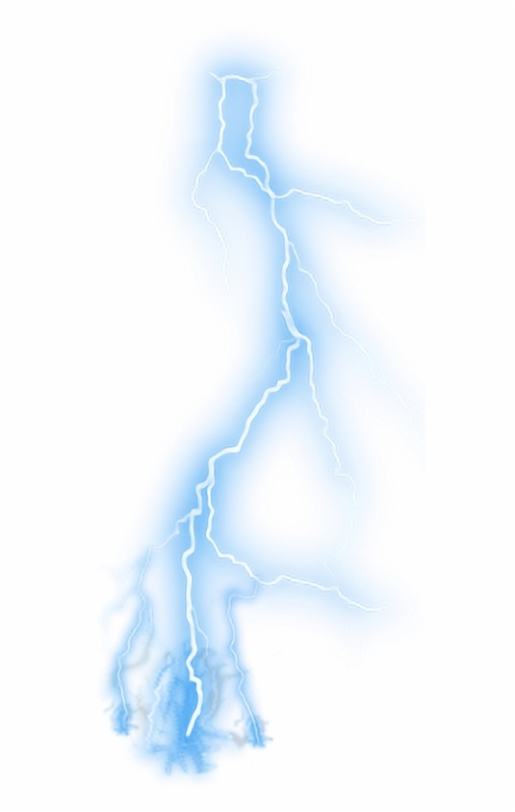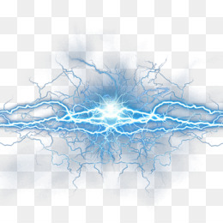

<https://www.cleanpng.com/free/lightning.html>

<https://www.sccpre.cat/show/bbxiRT_lightning-lightningbolt-neon-bluelightning-storm-blue-lightning-clear/>

Due to the images that I tried to use wasn’t going to work so therefore I had to look for more transparent images so that it looks more better when it’s transparent.